|  |
| --- |
| [Brain Mets/Palliative/Oligo/Immuno](https://bit.ly/PalliativeRoR)| [Breast](https://bit.ly/BreastRoR) | [CNS/Peds](http://bit.ly/CNSandPeds) | [Constraints](https://bit.ly/RoRConstraints) | [GI](https://bit.ly/RoRGI) | [GU](https://bit.ly/GURoR) | [Gyn](https://bit.ly/RoRGyn) | [H&N/Skin](https://bit.ly/HNRoR) | [Heme](https://bit.ly/RoRHeme) | [Sarcoma](https://bit.ly/RoRSarcoma) | [Thorax](https://bit.ly/RoRThorax) | [**Rad Phys/Bio**](https://bit.ly/RORPhysBio)  [**www.RadOncReview.org**](http://www.radoncreview.org)  For best navigation, click on the table of contents to navigate and click on a subheader or header to return to the table of contents. Otherwise, use the Document Outline feature or control-F to search for a clinical trial of interest. Best held horizontally on mobile. Type '20 to see what's new.  **This document is a collaborative resource. All comments, corrections, and additions are welcome! Editing tips [**[**here**](https://docs.google.com/document/d/163jAwVLz8Wnno7jttJnDIM-4kTxkSSmj9XLP1W5pPJs/edit)**].**  **We are actively looking for editors of this section! Since we passed oral boards last year (2019), this will not be as actively updated.**  **2020 Gold Star sections: Instant Oncology [****Rad Physics****], [****Rad Bio****], and [****Statistics****] illustrations. Click on pictures for explanations!** |

[**StatPearls: BRCA 1 and 2**](https://www.ncbi.nlm.nih.gov/books/NBK470239/)*Last update: 11/28/2019.*

[**StatPearls: Cowden Syndrome (Multiple Hamartoma Syndrome)**](https://www.ncbi.nlm.nih.gov/books/NBK525984/) *Last update: 12/11/2019.*

[**StatPearls: Lynch Syndrome**](https://www.ncbi.nlm.nih.gov/books/NBK431096/)*Last update: 6/4/2019.*

[**StatPearls: Neurofibromatosis**](https://www.ncbi.nlm.nih.gov/books/NBK459329/)*Last update: 11/29/2019.*

[**StatPearls: Tumor-Suppressor Genes**](https://www.ncbi.nlm.nih.gov/books/NBK532243/) *Last Update: 11/15/2018.*

[**StatPearls: Radiation X-ray Production**](https://www.ncbi.nlm.nih.gov/books/NBK537046/) *Last update: 9/24/2019.*

# Table of Contents

|  |  |
| --- | --- |
| **Physics**  Raphex  In-service Review  Chapter 1: Structure of Matter  Chapter 2: Nuclear Transformations  Chapter 3: Production of X-rays  Chapter 4: Clinical Radiation Generators  Chapter 5: Interactions of ionizing radiation  Chapter 6: Measurement of Ionizing radiation  Chapter 8: Measurement of absorbed dose  Chapter 9: Dose distribution and Scatter Analysis  Chapter 10: A System of Dosimetric Calculations  Chapter 11: Tx Planning I: Isodose distributions  Chapter 12: Tx Planning II: Pt Data, Corrections and Setup  Chapter 13: Tx Planning III: Field Shaping, Skin Dose, and Field Separation  Chapter 14: Electron beam therapy  Chapter 15: Brachytherapy  Chapter 19: 3D Conformal RT  **Instant Oncology: Physics**  **Instant Oncology: Rad Bio**  **Instant Oncology: Statistics**  Biostats | **Radiobiology**  Boards  Radiobiology pearls  DNA damage and ionizing radiation  Cell survival  Mechanisms of radiation-induced cell death  Molecular Techniques in Radiobiology  The cell cycle and DNA repair  Cyclins and Kinases  Checkpoint Pathways  P53  NHEJ and HRR  Cancer Biology  PARP inhibitors  CDK 4/6 inhibitors and PI3K inhibitors  Hereditary DNA repair syndromes  Common DNA Damage Assays  Effects of Oxygen  Radioprotectors  Chemo from the Perspective of a Radiation Biologist  Effects of Hyperthermia  Effects of acute TBI  Effects of Radiation on the Embryo/Fetus  Radiation Protection  Radiation Carcinogenesis  Clinical Response of Normal Tissues |

# Physics

## 

|  |
| --- |
| Important equations and values   * 1 Ci = 3.7 x 10**^10** disintegrations/sec [Bq]. 1mCi = 37 MBq.   + 2.5 mCi Cs-137 = 1mg Ra-226. * Gy = J / kg = 100 rad. 1 Sv = 100 rem. * 1 eV = 1.6 x 10^-19 J * 1R = 2.58 x 10-4C/kg air * D (cGy) = 0.876*R. * E=hν, c =λν where h (Planck's constant = 6.63 x10^-34 Js). * 1 amu = 1.66 x 10-27 kg (1/12 of the mass of C-12). * s = Ssinθ is size of apparent focal spot. Average anode angle 6-17 degrees. Therapy tubes use an angle of about 30 degrees.   + S is width of target (actual focal spot).   + Apparent focal spot sizes 0.1-2 x 0.1-2 mm for diagnostic, while 5-7 x 5-7 mm for therapeutic. * 1 Sv = 100 rem * 1 V = J/C; 1 A = C/s. |

## 

## Raphex

* **TD = Tpot/(1-Φ)**. TD = Volume doubling time. Tpot = potential doubling time. Φ = cell loss factor.
  + Ex: For a cell loss factor of 90% and a Tpot of 10 days, what is the volume doubling time?  
    A: 100 days. 0.9 = 1-(10/x). 0.1 = 10/x ∴ x = 100 days.
  + Sarcomas have a lower cell loss factor than carcinomas.
  + Cell loss factor is the dominant growth rate determining factor in carcinomas.
* **1/Effective t½ = 1/Physical t½+ 1/Biological t½.**
* λ = 0.693/t1/2
* A=Aox e- λ t
* **HVL = 0.693/μ** 
  + Homogeneity coefficient = HVL1/HVL2
  + HVL for superficial beams (50-150 kVp), 1- 4mm Al (Z=13).
  + HVL for orthovoltage beams (150-500 kVp) 0.5- 4 mm Cu (Z=29).
* **Electron range**: **"5-4*-3-2 Rule"**: RDmax-R90-R80-Rp
  + *3.2, or 3 with some sources.
  + 50% IDL 2.33
  + Attenuation = 2 MeV/cm of water traversed. "Continuous Slowing Down Approximation"
* **Photon dmax**: **Rule of thumb - For dmax, divide by four until >10 MV**.
  + Co60 0.5 cm, attenuation ~5%/cm.
  + 4 MV 1.0 cm.
  + 6 MV 1.5 cm, attenuation ~4%/cm.
  + 10 MV 2.5 cm.
  + 15 MV 3 cm.
  + 18 MV 3.5 cm, attenuation ~3%/cm.
* **Optical density = log(Io/It).**
  + Io = transmission values measured before an exposure.
  + It = transmission values measured after an exposure.
  + **Film speed**= 1/(Exposure needed to produce OD of 1 above baseline density).
    - Exposure = 1/400= 2.5 mR.
    - OD >2 is generally not usable, as represents only 1% transmission.
* **Gap = S1 + S2 = d(0.5L1/SSD1 + 0.5L2/SSD2)** [[Slide 32](https://www.slideshare.net/DrAbaniKantaNanda/craniospinal-irradiation-104549528)]
* Equivalent square: **2LW/(L+W)**.
  + Corrected square size of irregularly blocked fields = Equivalent square*√(1-percent area blocked).
* **Average half life = 1.44 * t(½)**.
* Wedge angle = 90 - ½ (Hinge angle).
* W (penumbra width) = s (source size) x (SSD+d-SDD)/SDD. [[Slide 22](https://slideplayer.com/slide/5908434/)] *Penumbra increases as SSD increases.*
* Cerrobend needs to be 20% thicker than lead.
  + Recall: Practical range in mm for lead = E/2 + 1 mm.
* Equivalent square: 2LW/(L+W).
* **Cut out correction factor necessary if R(cm) < √E(MeV)**.
  + R(cm) is the shortest distance from calc point to edge of the cutout.
* 1 HU is a 0.1% change from μ tissue. Equation: (μtissue.μwater)/μwater x 1000.
* **Chest x-ray 80 keV, CT brain 120-140 keV, PET 511 keV**.
* Photoelectric ∝ Z3/E3
* Compton dominates at MV in water. We want low energy (1/E), dependent on electron density.
* Pair: 1.022 MeV. ∝ Z2
* Rx to SAD: Use TMR, inverse square correction needed.
* Rx to SSD: Use PDD, no inverse square needed.
* **Reportable misadministration**
  + 50% difference per fraction
  + 20% difference for entire treatment
  + Wrong site
* **Brachy dose rate**: LDR between **0.4-2 Gy/h** and HDR **>12 Gy/h**.
* Transmission through MLCs are usually around 1-2%, while interleaf transmission can be around 3%.  
  (It's easier to go around MLCs than through them)
* Tube arcing: when no useful beam is produced in an x-ray tube. For example, insufficient vacuum can cause this.
* Mass energy absorption coefficient excludes Bremsstrahlung (radiative loss).
* T/P do not influence HDR, 60-Co and TLD dose rates. Linacs can theoretically be affected, but sealed monitor chambers or internal sensors should be able to correct for T/P variations. Independent vented ion chamber output will vary with T/P.
* Effective point of measurement for photon DD with an ion chamber is upstream from chamber center by 0.6 and multiplied by cavity radius.
* Increased E electron beams "pinch in" at shallow depths and "bow out" at deeper depths. Lower energies / isodose lines always bow out, regardless of depth.
* Ultrasound waves are proportional to stiffness of medium and inversely proportional to density of medium.
* Noise in images is decreased by increased fluence.
* Total dose = initial dose rate x 1.44.

|  |  |
| --- | --- |
| **Dose from imaging**: AAPM TG-180 [[Ding Medical Physics '18](https://aapm.onlinelibrary.wiley.com/doi/full/10.1002/mp.12824)]   * One banana 1 μSv [[Banana Equivalent Dose](https://en.wikipedia.org/wiki/Banana_equivalent_dose)] * Flight from NY-LA 0.03 mSv * X-rays / MMA: < 5 mSv * Orthogonal kV: 2-10 mSv * Orthogonal MV: 1-5 cSv * kV CBCT: 0.5 - 4 cSv (As little as 1 cSv in third trimester associated with increased cancer) * Cardiac Cath: 1-4 cSv * Diagnostic CT: 3-5 cSv * MV CBCT: 2.5-16 cSv, although tomo MV CBCT may be as low as 1 cGy. * Full body CT or PET/CT: 10 cSv (<10 cSv may cause preimplantation failure/death, but not malformations). * TIPS: 40-140 cGy (20 cSv chronic exposure associated with increased human cancer)   **Doses required for effects in the embryo/fetus**:   * **Preimplantation** (**0- 9 days**): As little as 5-15 cSv results in prenatal death.   "All or nothing" - failure to implant or undetected death.   * **Organogenesis** (**10d- 6w**): < 10 cSv does not appear to be associated with risk of malformations, but there is no way in hell NRCP or IRCP will recommend this a "safe" dose to the fetus. Instead, they recommend 0.5 mSv/mo or 5 mSv during declared pregnancy. * **Fetal period** (**6w- birth**): 1 cSv is associated with a ~40% increased relative risk of cancer, absolute excess risk ~6%/Gy. These risk estimates are high, but certainly not zero. Risk of mental retardation is ~40%/Sv from months 2-4, decreasing to ~10%/Sv from months 4-6. The increased risk for mental retardation at months 2-4 as compared to months 4-6 is because neural cells migrate to their sites of function during this period.   TL;DR: A diagnostic CT or a few kV CBCTs can lead to prenatal death in the pre-implantation phase (5-15 cGy), though may not influence malformations during the organogenesis period (< 10 cGy may be "safe"). The risk for malignancy is highest during the third trimester and is associated with doses as low as one kV CBCT (1 cGy). Something about neural stem cells migrating during months 2-4 of development. | |

[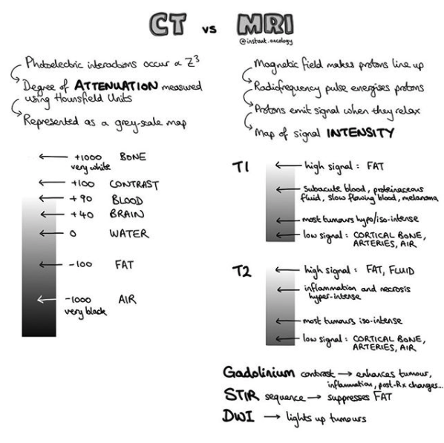](https://www.instagram.com/p/B-d8KlUAhCP/?utm_source=ig_web_copy_link)

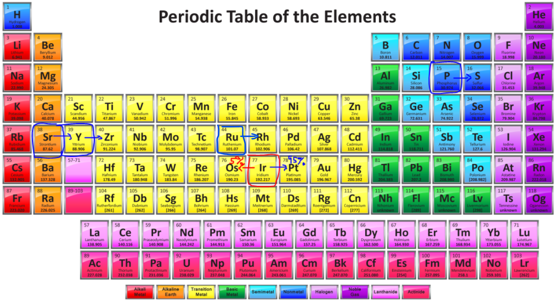

|  |
| --- |
| **Pure β- emitters**: Ir-192, Ru-106, Sr-90, Y-90, and P-32. **"I'm Rully SorrY Pal"** (see periodic table above). 74d, 1y, 28.8y, 64h, 14d.  Y-90 can achieve secular equilibrium with Sr-90.   * **Ir-192** has a halflife of 73d (NOT 60 d like I-125) and is *mostly* β- (95%, 5% is by EC). Max E 1.06 MeV, average E 380 keV. * Co-60 has a halflife of 5.26y, and an average E of 1.25 MeV.   **Rules of thumb for decay**: 10% after 3.3 half lives, 1% after 6.6 half lives, 0.1% after 10 half lives Co-60, I-125, Ir-192 and Pd-103 are produced by neutron bombardment, while Cs-137 is a nuclear fission product. F-18 is created by placing in a charged particle beam (cyclotron). Ra-226 = natural isotope.  From this information, it makes sense that Pd-103 and I-125 may be shielded using a thin piece of metal while Ir-192 requires a large afterloader for proper shielding. Ra-226, Cs-137 and Co-60 really aren't used any more due to the thickness of shielding required and extremely long half lives, among other things.   * **Cs-137** 2.3%/**y**; **Co-60** 1%/**mo**; **I-125**/**Ir-192** 1%/**d**; **Pd-103** 4%/**d**. **Ra-226** Ra-222. * **30y**; **5.26y**; **60d**/**74d**; **17d**. 1600y 4d * **662 keV** **1.25 MeV** 28keV/**380keV** 21 keV **830 keV** * 5.5 mmPb 10.5 mmPb 0.025/~2.5 mmPb 0.008 mmPb 8.0 mmPb Half value layers.   Practically all of the low energy sources decay by electron capture.  LDR is between 0.4-2 Gy/h and HDR >12 Gy/h. |

## In-service Review

* TG-21 [1983]: Plastic phantoms allowed. **Supplanted by TG-51**.
* TG-51 [1999]: Water phantoms. Treatment energies above cobalt 60.
  + TG-51: Quality of MV photon beam is PDD at 10 cm depth; quality of electron beam is R50.
    - Quality of lower energy beams is its ionizing potential in kVp combined with HVL.
    - Don't use parallel plate chambers unless R50 ≤ 2.6 cm per TG-51 (e.g. ≤ 6 MeV).
* TG-54: < 2 Gy for entire treatment.
* TG-59 [[1998](https://aapm.onlinelibrary.wiley.com/doi/abs/10.1118/1.598232)]: HDR-BT treatment delivery.
  + Check source placement to the millimeter every day.
  + Do not need to check source output every day, as it can be calculated by the computer. Calibrate upon delivery.
* TG-61 [2001]: 40-300 kV x-ray beams. Basically, up to orthovoltage.
  + HVL for superficial beams (50-150 kVp), 1- 4mm Al (Z=13).
  + HVL for orthovoltage beams (150-500 kVp) 0.5- 4 mm Cu (Z=29).
* TG-76 [2006]: Respiratory motion. If ≥ 5mm, there is room for gain with 4D.
* TG-100 [2016]: Risk analysis methods. Failure Modes and Effects Analysis (FMEA).
* **TG-128** [[MP '08](https://www.aapm.org/pubs/reports/rpt_128.pdf)]: **QA for Prostate Brachytherapy U/S Systems**
  + Annual: Needle template alignment, Axial and lateral resolution, grayscale visibility, depth of penetration, and volume measurement accuracy.
* ICRU 62: ITV = CTV + IM.
* High Z are unstable due to the short range of strong nuclear force.
* Most stable atomic nuclei have fewer protons than neutrons and an even number of protons.
* Why does the neutron to proton ratio increase above Z=20? Protons experience strong nuclear and coulomb forces. As protons are added, primary interaction is repulsion (Coulomb forces), so excess neutrons are needed to buffer protons from one another.
* TMR does not include effects of inverse square law attenuation therefore does not decline as rapidly as PDD.
* Mass of nucleus is slightly smaller than protons plus neutrons due to their nuclear bonding energy (i.e. mass defect).
* For 12 MeV: If low Z, then likely ionizing events with atomic electrons. If high Z, then inelastic with nuclei (bremsstrahlung).
* **Quality assurance**:
  + **Plastic cube with metal ball in center** checks coincidence of **MV and KV** imaging.
    - Single angle test. Checks coincidence of MV and KV imaging from one angle (see Winston-Lutz below).
    - This is done DAILY!
  + **Winston-Lutz**: **MV** imaging to check coincidence between gantry isocenter and laser alignment.
    - This also uses a plastic cube with a ball in the center, but differs as it checks from four angles.
    - This is done MONTHLY.
  + **Spoke/Star Shot**: Determines radiation isocenter by exposing film to different collimator, gantry and couch positions.
    - Make field width 1 cm with MLCs, and make sure line of intersection is ≤ 1mm.
    - This is done ANNUALLY.
  + **ACR/AAPM Technical Standard for the Performance of HDR-BT Physics** [[2015](https://www.acr.org/-/media/ACR/Files/Practice-Parameters/hdr-brachyts.pdf?la=en)]
  + **TG-142** [[MP '09](https://aapm.org/pubs/reports/rpt_142.pdf)]: Check kV imaging and MV isocenter weekly.
    - Dosimetry: Check X-ray/electron constancy daily (3%), monthly (2%). Calibrate dose output annually.
    - Mechanical: 2mm for daily and monthly, while 1mm for annually.
      * Daily: ± 1 mm radiation and mechanical isocenter for SRS.
      * Daily: ± 2 mm radiation and mechanical isocenter for IMRT.
      * Monthly: Coincidence between light field and radiation field.
    - Safety: Door locks, etc.
    - MLC:
      * **Daily**: **Picket fence**.
      * Monthly: MLC travel speed and accuracy.
      * Annual:
        + MLC transmission: ± 0.5% from baseline.
        + Star/**spoke shot**: Make field width 1 cm with MLCs, goal to have line of intersection of ≤ 1mm.
        + Step and shoot test.
        + Moving window IMRT.
    - Imaging: Applies to kV and MV.
      * **Daily**: **kV and MV coincidence isocenters** ± 1 mm for SRS/SBRT, ± 2mm for non-SRS/SBRT.
      * Monthly: Check contrast and spatial resolution (± 1 mm for SRS/SBRT, ± 2mm for non-SRS/SBRT)
      * Annual: Check imaging dose.
  + **AAPM Practice Guidelines for SRS/SBRT (MMPG 9a)** [[Halvorsen AAPM '17](https://www.ncbi.nlm.nih.gov/pmc/articles/PMC5874865/)]
    - Daily: Laser localization 1mm. Collimator size 2mm. Radiation isocentricity (1 mm SRS, 1.5mm SBRT), IGRT positioning/repositioning (1mm SRS, 2mm SBRT). Output constancy ± 3%.
    - Monthly: Radiation isocentricity for all gantry/couch/collimator positions (1mm SRS, 1.5 mm SBRT). Treatment couch position indicators (1mm/0.5 degrees). Output constancy ± 2%.
    - Annually: End to end test, Coincidence of radiation/mechanical isocenter ± 1mm, Accelerator output ± 1.5%, MU linearity ± 2%.
  + **End to End test**:Measures uncertainty for a given treatment technique by doing a plan totally in a phantom (i.e. Sim, plan, then treat a phantom). Needs to occur once yearly.
* CT uses 120-140 kVp (photoelectric)

## 

[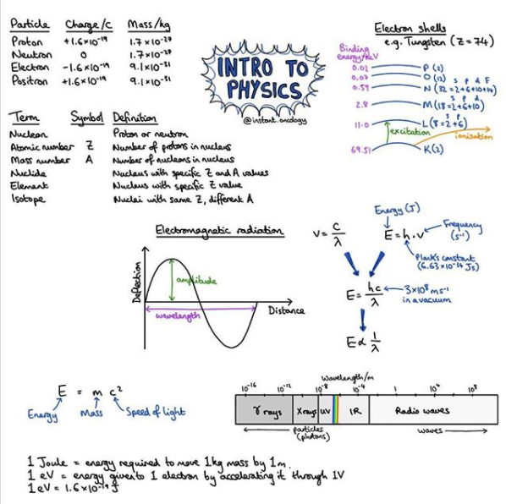](https://www.instagram.com/p/B-aRMvGg4Hn/?utm_source=ig_web_copy_link)

## Chapter 1: Structure of Matter

* IsotoPe: same P
* IsotoNe: same N
* IsobAr: same A
* IsoMer: same element and mass number in diff state.
* Avogadro: 6.023 x 10^-27
* Strong > EM > weak > gravity.
* E=hν, E=hc/λ.

[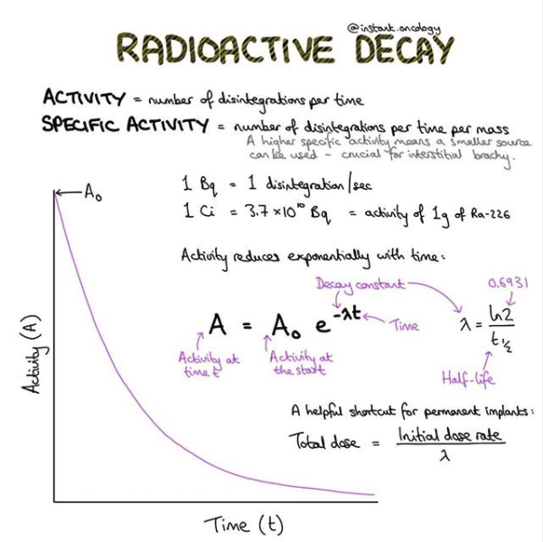](https://www.instagram.com/p/B-enUfiAkAQ/?utm_source=ig_web_copy_link)

[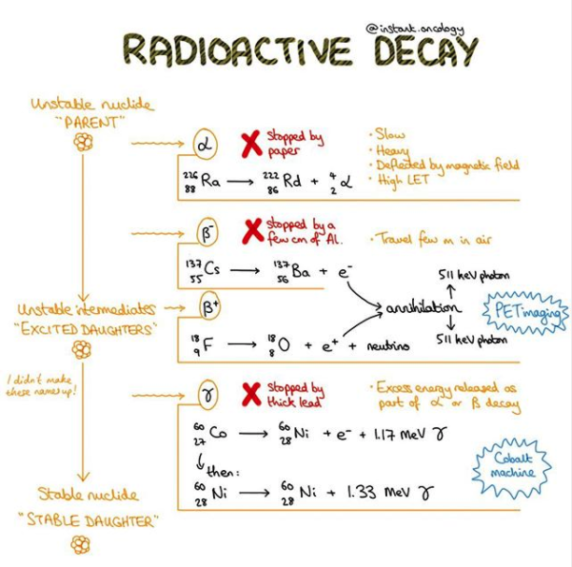](https://www.instagram.com/p/B-gvn1QgdZ3/?utm_source=ig_web_copy_link)

## Chapter 2: Nuclear Transformations

|  |
| --- |
| * 1 Ci = 3.7x10**^10** disintegrations/sec [Bq]. 1 mCi = 37 MBq. * 1 Gy = 1 J / kg = 100 rad. * 1 Sv = Gy * QF or WF = 100 rem |

* When source is completely decayed, use average lifetime
* α decay: Y + He + Q
  + Q = disintegration E, or mass diff B/T parent and daughters given as KE.
* β- decay: β+ + antineutrino + Q
* EC: converts proton to neutron. Daughter + neutrino + Q (competes with β +)
* Internal conversion: takes E from nucleus to kick out e- (similar to PE effect).

[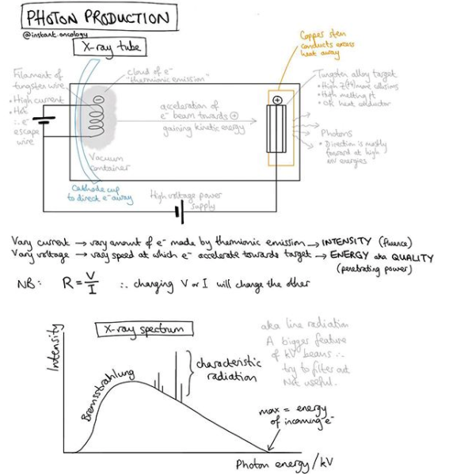](https://www.instagram.com/p/B7ySUqSJZy4/?utm_source=ig_web_copy_link)

## Chapter 3: Production of X-rays

* Heel effect: s=Ssinθ is size of apparent focal spot. Average anode angle 6-17 degrees. Therapy tubes use an angle of about 30 degrees.
  + S is width of target (actual focal spot), while s is the apparent focal spot.
  + Want apparent focal spot to be small for good spatial resolution.
* Peak voltage = V√2
* Half wave rectifiers will require more mAs for same kVp.
* Filament current > tube current > tube voltage in terms of affecting x-ray tube output the most.
  + Output increases linearly with tube current, and increases with square of tube voltage.
* **Dose rates**:
  + ≥ 40-50 Gy/s: FLASH-RT.
  + 2k MU/min (~20 Gy/min) common for SRS/SBRT techniques.
  + 400-600 MU/min (~4-6 Gy/min) for standard 3D treatments.
* **Bremsstrahlung**: rate of E loss/cm ∝ E and Z2.
  + From inelastic collisions with atomic nuclei.
  + Bremsstrahlung efficiency <<1, so higher electron current is needed in photon mode. Rate of brem increases ~linearly with increasing energy, so for lower energy x-rays, higher electron current is required to produce the same dose rate.
    - At diagnostic energy, efficiency of x-ray production is around 1%.
    - At therapeutic energy, efficiency of x-ray production is around 50%.
  + λ min = 1.24 / kVp nm.

[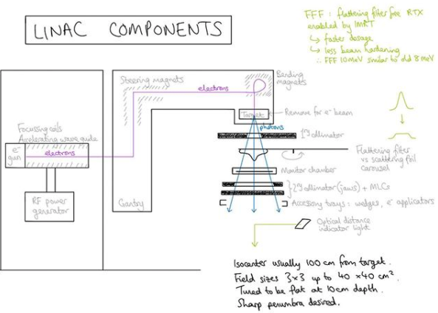](https://www.instagram.com/p/B6l2qNtpRpl/?utm_source=ig_web_copy_link)

## Chapter 4: Clinical Radiation Generators

* Grenz (< 20 kVp), **Contact** (40-50), **Superficial** (50-150), **Orthovoltage** (150-**500 kVp**), Supervoltage (500-1000), Megavoltage
  + Contact: 2cm SSD. Superficial skin, low/middle third of rectum
  + Superficial: 15-20cm SSD. 90% PDD 5mm.
  + Ortho: 50cm SSD. 90% PDD 2cm.
  + Super: initial issue was insulating a high voltage transformer.
    - Resonant transformer: 300-2000 kVp. Electrical insulation is pressurized freon gas.
  + Kilo: Resonant transformer to insulate voltages >300 kVp
* MV units
  + Betatron: inherently low electron beam current devices→ Low dose rate x-rays
  + Microtron
  + Cyclotron:
* Accessories
  + **Magnetron**: **Makes Microwaves.** Frequency within each pulse 3000Mhz.
  + Klystron: microwave amplifier. Velocity modulation of microwaves in buncher cavity. In catcher cavity, pulses charges induce retarding electric field which decelerates electrons and is converted to high-power microwaves.
* **Cobalt-60**

Produced by slow neutron bombardment of Co-59. Co-60 decays to Ni-60 by β decay (0.32 MeV) which is absorbed in a double welded source capsule. RoR

* + ~1% decay per month. Replace at half-life. t1/2 = 5.26 years
  + 1.33 MeV and 1.17 gamma decay.
  + D max 0.5 cm
  + Transmission penumbra: Through collimator block.
  + **Geometric penumbra** via source geometry:
    - Pd = s (SSD + d - SDD)/SDD.
* **Cs-137**
  + 0.66 MeV gamma decay by β- decay.
  + t1/2 = 30 years.
  + If used in "dirty bomb", it would be disastrously effective due to long half life and ability to vaporize. **Prussian blue** is FDA approved as it binds to cesium within the GIT, promoting excretion from the intestines and indirectly from blood.
* 3 GHz microwaves are used within accelerator structures
* X-ray mode uses 1000:1 electron current as opposed to electron mode.
  + At diagnostic energy, efficiency of x-ray production is around 1%.
  + At therapeutic energy, efficiency of x-ray production is around 50%.
* **Ranges of heavy particles**:
  + H-2 has twice the range of H-1. R1/R2 = (M1/M2)(Z2/Z1)^2

[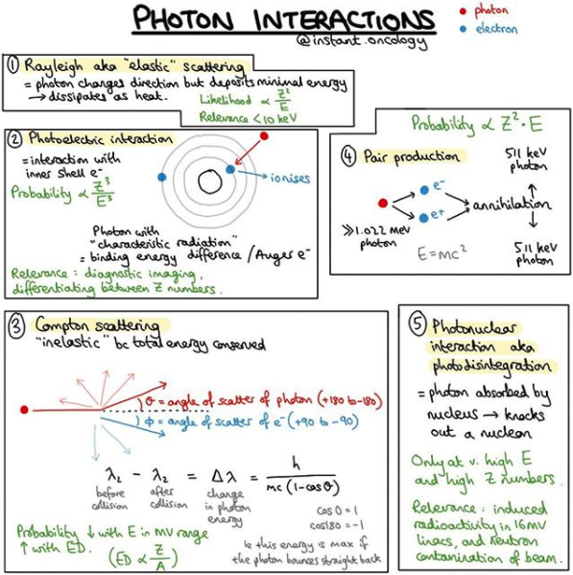](https://www.instagram.com/p/B9GujfGgVJ4/?utm_source=ig_web_copy_link)

[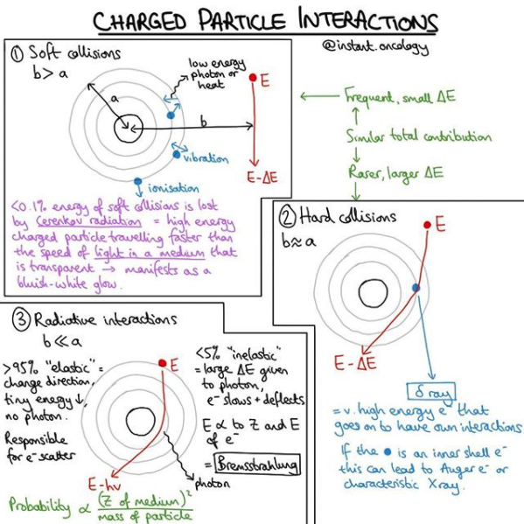](https://www.instagram.com/p/B9H9O4mA5hn/?utm_source=ig_web_copy_link)

## Chapter 5: Interactions of ionizing radiation

* **Coherent scatter**: This is essentially a low E version of Compton (photon changes directions), but an electron is not ejected.
  + Inversely proportional to λ-4, therefore blue light more likely to undergo coherent scatter (i.e., why the sky is blue).
* **Photoelectric** is proportional to Z3/E3. Predominates up to ~ 25 keV, dominates in X-rays and CT - **140 kVp**.

A photon is absorbed, while an electron is ejected, creating characteristic X-rays.

* + The probability is greatest when the photon energy equals that of the binding energy of the electron (usually inner shell).
  + Auger electrons may be created by absorption of characteristic X-rays -"internal PE effect".
  + Recall- IC: takes E from nucleus to kick out e- (similar to PE effect).
* **Compton** depends on electron density and decreases with increasing E. Dominates in soft tissue from 25 keV - 10 MV in soft tissue.

Part of the photon's energy is absorbed, and the photon is scattered. A free electron is ejected.

This is the primary interaction for radiation therapy, but is virtually useless in diagnostic imaging.

* + The probability is greatest when the photon energy is much greater than the binding energy of the electron.
  + **Compton is *not* dependent on Z!** The Compton effect usally interacts with outer shell electrons.
  + **E៵' = E៵/ (1 + α (1-cos θ).**
  + Maximum energy of backscattered photon 0.255 MV, while maximum energy of side-scattered photon 0.511 MeV.
* **Pair Production**: ≥ 1.022 MeV. It is proportional to EZ2.
  + Interaction with the electromagnetic field of the nucleus, instead of an orbital electron.
* **Photodisintegration**: high energy x-ray has nucleus kick out neutron, ~7 MeV threshold.
  + Neutron production above 7 MeV - consider water or borated polyethylene to shield neutrons.
* **"25 keV - 10MV rule" < 25 keV PE; 25 keV-10 MV Compton; >10 MV PP** for soft tissue density (Low Z).
* **HVL = 0.693/μ** 
  + Homogeneity coefficient = HVL1/HVL2.
  + HVL for superficial beams (50-150 kVp), 1- 4mm Al (Z=13).
  + HVL for orthovoltage beams (150-500 kVp) 0.5- 4 mm Cu (Z=29).

|  |
| --- |
| **Electron range**: **"5-4*-3-2 Rule"**: RDmax-R90-R80-Rp   * * 3.2, or 3.3 with some sources. * 50% IDL 2.33 * Attenuation = 2 Mev/cm of water traversed. "Continuous Slowing Down Approximation" * For R90, Khan used to use 4 back in the day, while Raphex prefers 3.2 and McDermott and Orton prefers 3.3 cm.   **Photon dmax**: **Rule of thumb - For dmax, divide by four until > 10 MV**.   * Co-60 0.5 cm, attenuation ~5%/cm. * 4 MV 1.0 cm. * 6 MV 1.5 cm, attenuation ~4%/cm. * 10 MV 2.5 cm. * 15 MV 3 cm. * 18 MV 3.5 cm, attenuation ~3%/cm. |

## Chapter 6: Measurement of Ionizing radiation

* 1R = 2.58 x 10-4C/kg air
* Don't use parallel plate chambers unless R50 ≤ 2.6 cm per TG-51 (e.g. ≤ 6 MeV).
  + Typical plate separation is 2 mm.
  + 6 MV beams are used in calibrations and MV CBCTs.
* Calorimeter - measures absorbed dose directly.
* **Calibration of meters**
  + **Survey meters**: **Yearly with ADCL** (Accredited Dosimetry Calibration laboratory).
  + **Farmer chamber**: **Yearly** by Physicist who intercompares with ADCL-calibrated dosimetry system.
    - Does not actually have to be sent to the ADCL.
  + **Well chambers**:Every **two years**. May be used to measure HDR, LDR and beta sources.
* **ACR/ASTRO Practice Parameter for the Performance of Therapy with Unsealed Radiopharmaceutical Sources** [[Revised '19](https://www.astro.org/ASTRO/media/ASTRO/Patient%20Care%20and%20Research/PDFs/PracPara_UnsealedRadiopharmSources.pdf)]

## Chapter 8: Measurement of absorbed dose

* Exposure only related to gammas, KERMA is neutrons and gammas. KERMA is a measure of the ability to ionize air. Not useful for 3MeV due to the difficulty of measurement.
* 1R= 2.58x10-4 C/kg air
* X=Q/m
  + Only includes charge from original gamma, not brehm or annihilation by electrons.
  + Add 33.97 J/eV stuff here
* PTP=(273.2+T)/(273.2+22)*760/P.
  + Standard conditions: T=22C and P=760 mmHg.
* Optical density = log(Io/It). Transmission of 10% results in OD of 1. Transmission of 1% results in OD of 2.
  + Io = transmission values measured before an exposure
  + It = transmission values measured after an exposure.
  + OD(base+fog) is typically 0.2. This accounts for the plastic film base and fog of Ag grains that appear with development.
  + Net OD = OD - OD(base + fog).
* Ion chamber 3-6mm, TLDs 3x3x0.5 mm, diodes ~1mm.
  + Add TLD vs. OSMS stuff here

[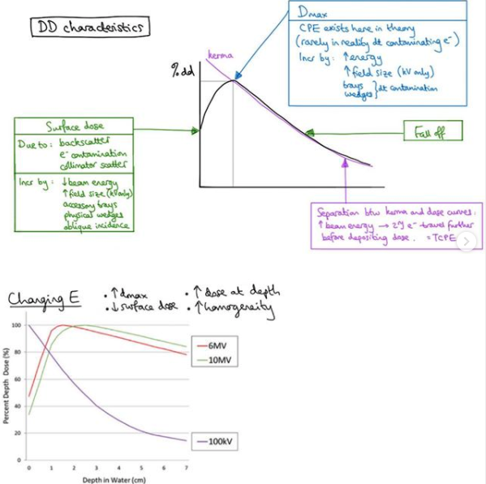](https://www.instagram.com/p/B6yK20upRzd/?utm_source=ig_web_copy_link)

## Chapter 9: Dose distribution and Scatter Analysis

## Chapter 10: A System of Dosimetric Calculations

## Chapter 11: Treatment Planning I: Isodose distributions

* We want an agreement of 2% or less up to 20 cm depth. An agreement within 2 mm of the penumbra region is acceptable.
* Any factor that increased PDD will decrease tissue lateral effect. PDD increases with increasing SSD, increasing field size, and increasing energy.
  + **Effect of field size**: For smaller fields, one may assume PDD at a point is the result of primary radiation. In this case, the contribution of scattered photons to PDD is negligibly small or 0. But, as field size increases, the contribution of the scattered radiation to absorbed dose increases. As this increase in scattered dose is greater at larger depths than Dmax (past the *dose build up* region), the PDD increases with increasing field size.
    - Higher E photons are more forward scattered, so this field size effect is less pronounced at higher energies.
  + **Effect of SSD**: Photon fluence varies by inverse square law.
    - **Mayneord F Factor: F = [(f2+dm)/(f1+dm)]2*[(f1+d)/(f2+d)]2**
    - In general, Mayneord F factor overestimates increase in DD with increase in SSD (e.g. for large fields/lower energy where the proportion of scattered RT is relatively greater, the factor **(1+F)/2** applies more accurately.
    - **TAR** utilized to correct for varying SSD. It is a function of depth, field size and Energy.
      * No dependence on photon fluence, as TAR is a ratio at the same point. Instead, it is a function of depth.
    - **Backscatter Factor** (BSF): TAR at Dmax. Depends on beam quality and field size.
      * Peak Scatter factor (PSF) is measured in a phantom, and is in units of absorbed dose and not exposure like BSF.

## Chapter 12: Treatment Planning II: Patient Data, Corrections and Setup

* TAR/TMR does not depend on SSD and instead is fxn of depth and size.
* ƒ factor = 0.876 ( μen/ ρ)medair
  + This is absorbed dose in medium per Roentgen - dependent on photon energy except in air.

[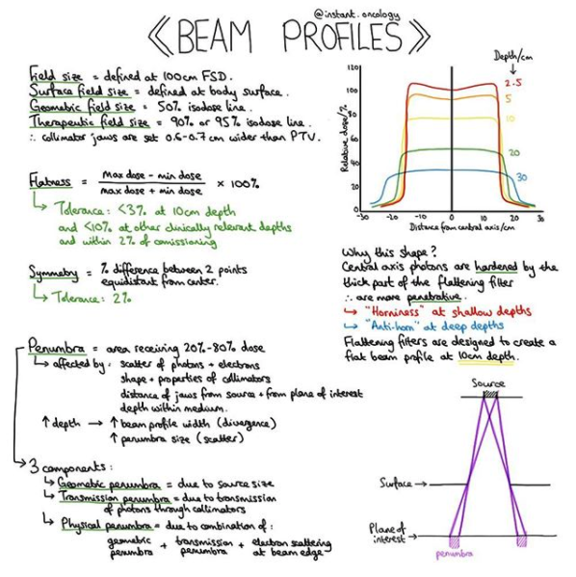](https://www.instagram.com/p/B-MzlA3gO99/?utm_source=ig_web_copy_link)

## Chapter 13: Treatment Planning III: Field Shaping, Skin Dose, and Field Separation

* Gap = S1 + S2 = d(0.5L1/SSD1 + 0.5L2/SSD2)

[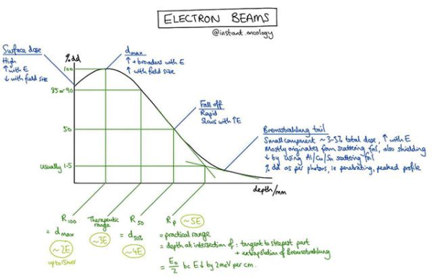](https://www.instagram.com/p/B8f_O8NAzrt/?utm_source=ig_web_copy_link)

## Chapter 14: Electron beam therapy

* **Coulomb force interactions**
  + Inelastic collision: Energy loss and direction change. **Collisional ∝ electron density; radiative ∝ EZ2**.
    - **Inelastic with atomic electrons**: **Collisional loss - Dose deposited locally**. Ionization (hard) vs. excitation (soft).
      * Low Z → ionizing events with atomic electrons.
      * Collision depends on electron density, which is inversely proportional to Z as higher Z have fewer electrons per gram and are more tightly bound. There is lower collisional potential in lead than water as lead has less electron density than water.
      * In water, most energy loss is collisional.
    - **Inelastic with nuclei: Radiative loss - Bremsstrahlung**. Dose *not* deposited locally.
      * High Z → bremsstrahlung production.
      * It's easier to generate higher MV photons, the electron current is less for higher energy.
      * Lead has high Z, so radiative loss more common in lead than water.
  + Elastic collision: No electron energy loss, only direction change.
    - Elastic collections with atomic electrons: Electron-electron scattering.
    - Elastic collisions with nuclei: Nuclear coulomb scattering.
* △ Ray: If KE acquired by stripped electron is large enough to cause further ionization.
* **Bremsstrahlung**: rate of E loss/cm is proportional to E and Z2
  + X-ray mode uses 1000:1 electron current as opposed to electron mode.
    - At diagnostic energy, efficiency of x-ray production is around 1%.
    - At therapeutic energy, efficiency of x-ray production is around 50%.
* **Electron range**: **"5-4*-3-2 Rule"**: RDmax-R90-R80-Rp
  + * 3.2, or 3.3 with some sources.
  + 50% IDL 2.33
  + Attenuation = 2 Mev/cm of water traversed. "Continuous Slowing Down Approximation"
  + For R90, Khan used to use 4 back in the day, while Raphex prefers 3.2 and McDermott and Orton prefers 3.3 cm.
* Don't use parallel plate chambers unless R50 ≤ 2.6 cm per TG-51 (e.g. ≤ 6 MeV).
  + Typical plate separation is 2 mm.
  + 6 MV beams are used in calibrations and MV CBCTs.
* Surface dose increases as energy increases.
* Spreading beam: Dual-scattering: 1st foil creates Gaussian, 2nd foil flattens out Gaussian.
* DD decreases as field size decreases
* Inhomogeneities: corrected for by coefficient of equivalent thickness (CET)
  + **Deff=d-z(1-CET)**. CET for a given material is e- density relative to water

[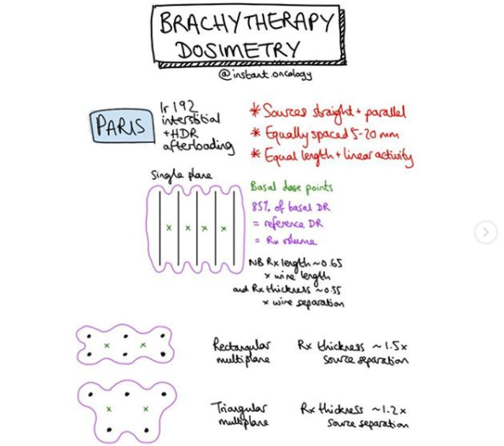](https://www.instagram.com/p/B708kE-J6HA/?utm_source=ig_web_copy_link)

[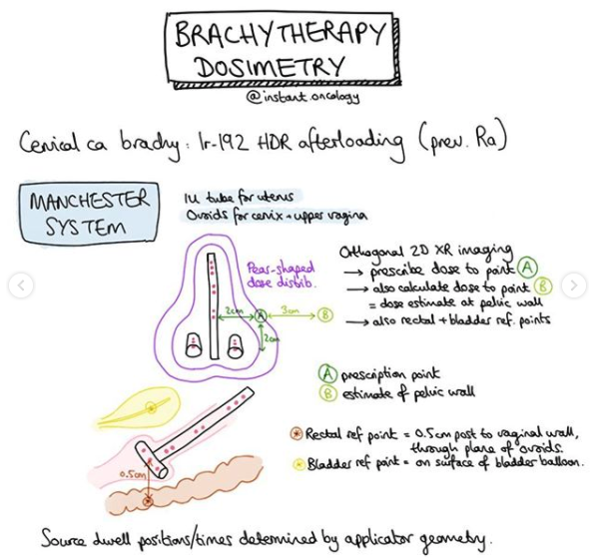](https://www.instagram.com/p/B708kE-J6HA/?utm_source=ig_web_copy_link)

## Chapter 15: Brachytherapy

* λ = 0.693/t1/2
* A=Aox e- λ t
* **Rules of thumb for decay**: 10% after 3.3 half lives, 1% after 6.6 half lives, 0.1% after 10 half lives  
  Co-60, I-125, Ir-192 and Pd-103 are produced by neutron bombardment, while Cs-137 is a nuclear fission product.  
  F-18 is created by placing in a charged particle beam (Cyclotron).

Ra-226 is a natural isotope.

* + **Cs-137** 2.3%/**y**; **Co-60** 1%/**mo**; **I-125**/**Ir-192** 1%/**d**; **Pd-103** 4%/**d**. **Ra-226** Ra-222.
  + **30y**; **5.26y**; **60d**/**74d**; **17d**. 1600y 4d
  + **662 keV** **1.25 MeV** 28keV/**380keV** 21 keV **830 keV**
  + 5.5 mmPb 10.5 mmPb 0.025/~2.5 mmPb 0.008 mmPb 8.0 mmPb Half value layers.
  + From this information, it makes sense that Pd-103 and I-125 may be shielded using a thin piece of metal while Ir-192 requires a large afterloader for proper shielding. Ra-226, Cs-137 and Co-60 really aren't used any more due to the thickness of shielding required and extremely long half lives, among other things.
  + Practically all of the low energy sources decay by electron capture (e.g. Pd-103 and I-125.
* LDR between 0.4-2 Gy/h and HDR >12 Gy/h.
* Pure β- emitters: I-131, Sr-89, P-32, Y-90, Ru-106.
* Lawrence force causes bending of beam (synchrotron).
  + F=mv2/r.

## Chapter 19: 3D Conformal RT

# Radiobiology

## Boards

* G1 has the longest variation, from < 1h to > 1wk.
  + For cells with longer G1, there is a peak of resistance in early G1.
* Testicles: Permanent sterility > 6 Gy single or 3 Gy fractionated.
  + Oligospermia 0.15 Gy (with 6w latency). Azoospermia 0.5 Gy. Recovery is dose-dependent (1y after 2 Gy).
    - The sperm maturation process is a little over two months.
  + The prepubertal female requires **12 Gy** for permanent sterility. Only 2 Gy premenopausal.
    - There is not a latent period nor temporary sterility in females.
    - The LD50 of human oocytes is estimated to be below 2 Gy. Older women are more radiosensitive.
    - Effective sterilizing dose at birth / 10y / 20y / 30y of 20→ 18→ 16→ 14 Gy [[Skrzypek AAEM '19](https://www.ncbi.nlm.nih.gov/pubmed/31885235)].
* AT, Nijmegen breakage syndrome - Think of ATM not being able to put the brakes on S-phase to repair DS-DNA.
  + MRE11/RAD50/NBS1 (MRN) is involved in sensing dsDNA breaks -- ATM indirectly interacts with MRE11, tethering MRN and making it suck at repairing DSBs. *What's ur MRN gurlll??*
  + ATM is present as dimer until damage occurs, then ATM autoP'lates on residue **Ser1981**.
* **Leukemia risk** (**non-linear**) dose-response which decreases with time (linear-quadratic)
  + Appears by 1-2 years, peaks at 7y, gone by 20y.
  + Thyroid: Begins at 4+y, peaks at 7-10y, does not completely disappear by 20y.
  + **Other solid tumors** (**linear**): 20y, sometimes 12+y, likely continues to increase.
* Fetus: Congenital malformations 2-6 weeks, Mental retardation 4x more common 8-15 weeks.
  + Neural stem cells are migrating to their final destination by 2-4 mo.
* 3 lethal aberrations: Dicentric and Ring (chromosome); Anaphase bridge (chromatid)
* **S phase cells that are resistant to x-rays are sensitive to heat**.
* The typical doubling time for human tumor cells is 48h in ideal growth conditions and nutrients. Typical volume doubling time is characteristically 40-100 days for carcinoma.
* **Tranduction**: introducing DNA into a cell using a viral vector.
* **Transfection**: Uses non-viral vector.
* **Transformation**: Cells are induced to achieve a malignant phenotype in a culture.

[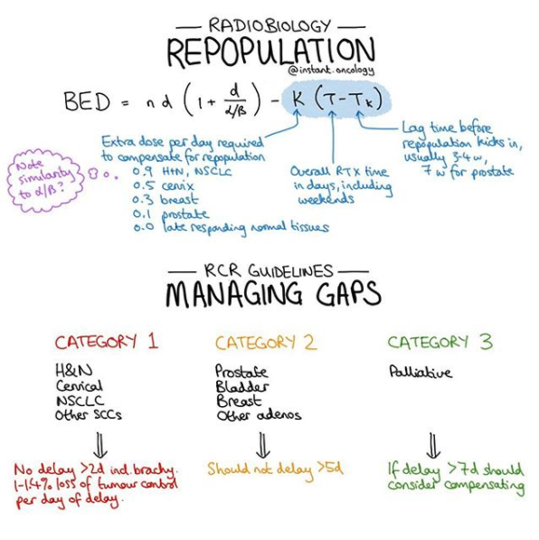](https://www.instagram.com/p/B91PfPlAtz9/?utm_source=ig_web_copy_link)

## Radiobiology pearls

* Three types of RT damage: LD, PLD, SLD. PLD is influenced by the environment. Delay mitosis then PLD→ SLD.
* **Repair** (Lasts around 2 hours in vivo.): Response to SLD or PLD.
* **Reassortment** (Lasts around 6 hours): May result in synchrony in cell cycling due to cell cycle checkpoints.
  + Generating synchronous cell populations: 1.) Mitotic harvest, 2.) HU, which kills in S phase and causes G1/S block or 3.) Inverse dose-rate effect: give 0.37 Gy/h! This causes cells to accumulate in G2, increasing cell kill.
* **Repopulation** (Early: 2-4w. Late: 6 weeks): Tumor cell proliferation during RT, can be problematic with long courses of RT.
* **Reoxygenation** (Occurs within hours to four days): Laboratory data suggest at least 3 days between fractions to increase possibility for re-oxygenation of tumor between fractions.
* **Radiosensitivity**

[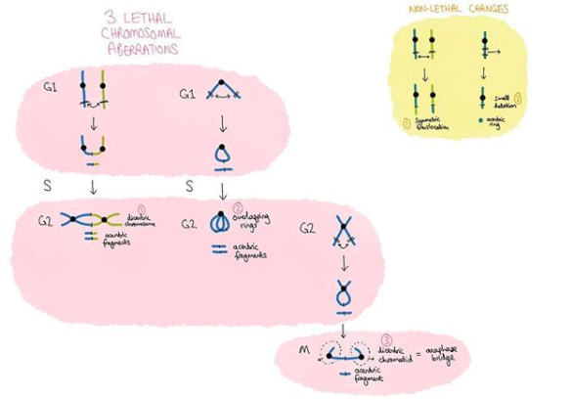](https://www.instagram.com/p/B6MUKCrBuMO/?utm_source=ig_web_copy_link)

## DNA damage and ionizing radiation

* **Direct**: Due to recoil proton or α particle - 1/3 of damage from sparsely ionizing radiation (i.e. low LET).
* **Indirect**: Hydroxyl radicals which ionize DNA - 2/3 of damage from sparsely ionizing radiation (i.e. low LET).
  + The hydroxyl radical has to be in close proximity to DNA: Range of OH radical is **4 nm** or twice that of dsDNA helix (**2nm**).
  + Initial ionization process lasts 10-15s, primary radicals produced by ejection of electron lasts 10-10s, hydroxyl radical lasts 10-9s, and DNA radicals subsequently produced have a half-life ~10-5.
  + Spur vs. Blob
    - Spur is a Small collection of OH radicals (e.g. 3 ion pairs)→ caused by sparsely ionizing RT.
    - Blob is a Big collection of OH radicals (e.g. 12 ion pairs)→ caused by densely ionizing RT.
    - Locally multiple damaged site = spurs/blobs dimension similar to helix width ∴ multiple radical attacks can occur.
* ៵ rays can induce base alterations, SSB, DSB and cross-linking.
  + Base alterations: Base excision repair, not a contributor to radiosensitivity except in XRCC1 deficiency.
    - SSB: Not a major contributor to radiosensitivity. PARP works here. PARP inhibition in the setting of impaired DS DNA repair (e.g. BRCAmt) may be an effective treatment modality.
  + NER is generally not considered important in radiosensitivity (Think: Xeroderma pigmentosum).
    - NER addresses bulky lesions e.g. thymidine dimers from UV light.
  + DSB:
    - HRR (late S/G2, when the template is available) - accurate.
    - NHEJ (most commonly G1) - error prone.
  + Chromosomal aberrations: Result from unrepaired or mis-repaired DSBs.
    - Nonlethal - symmetric translocations
    - Lethal - acentric, rings, dicentric, anaphase bridges.
      * 3 lethal aberrations: Dicentric and Ring (chromosome); Anaphase bridge (chromatid)
        + Anaphase bridge is two DSBs with one DSB in both chromatids of the same chromosome.
      * Acentric: Micronuclei form in the progeny of irradiated cells.
* LET [kEv/μm]: Generally, heavy particles and 15 MeV protons have high LET while photons and 150 MeV protons have lower LET.
  + High LET: 290 MeV carbon ions, X-particles, 15 MeV protons, and neutrons.
  + Low LET: 250 kVp X-rays, 200 MeV protons, 1.1 MV X-rays.
* RBE = D250/Dr, or relative dose to 250 keV X-rays or Co-60 or Cs-137 ៵ rays.
  + Greatest RBE for cell killing of 100 keV/um LET as it coincides with helix width of DS-DNA (2 nm). It then approaches unity at high LET.
  + Neutron RBE ranges from 5-20 depending on energy. The most damaging neutrons are in the range of 100 keV to 2 MeV.

[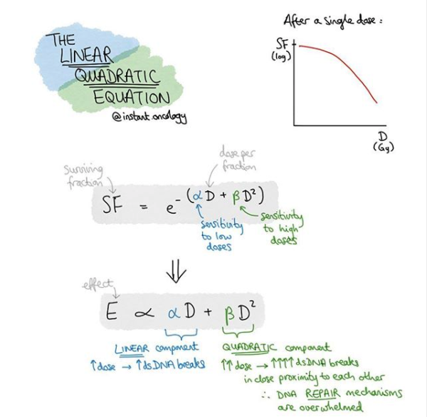](https://www.instagram.com/p/B8KTKtFgQ37/?utm_source=ig_web_copy_link)

[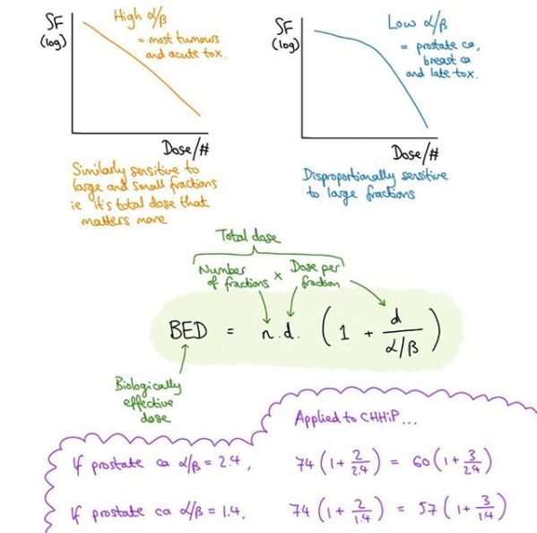](https://www.instagram.com/p/B7n2HIhJwMR/?utm_source=ig_web_copy_link)

## Cell survival

|  |
| --- |
| **Cell Survival: Multi-Target, Linear Quadratic and Universal Survival Model**   * **Surviving fraction** = colonies counted / [cells seeded * plating efficiency] * **Multi-Target**: Not really used anymore.   + Dx = dose of RT required to generate 37% cell survival (avg of 1 lethal event per cell).     - Typically 1-2 Gy for mammalian cells.     - Results in >1000 damaged bases, ~1000 SSBs, and 30-40 DSB per cell.   + D10 = dose required to kill 90% of the population = **2.3 x D**0 * **Linear quadratic model** (LQM): More consistent with our current understanding of RT damage.   + **Exponential cell kill**: **S = e-αD - βD^2**   + Two components of cell kill:     - **α component**: **Linear, single event causes aberration**. Related to dose (αD).       * At low doses, DSBs likely to be caused by a single particle.     - **β component**: **Curved, separate events cause aberration**. Related to dose2 (βD2).       * At higher doses, DSBs likely to be caused by multiple particles..     - **α/β ratio**: **The point at which alpha and beta components have an equal contribution to cell killing**.       * Most tumors and early-responding tissue like mucosa have high α/β = 10.       * Some tumors like prostate and late-responding tissues like spinal cord have low α/β = 3. * **Universal survival model** (USM): Recently proposed due to LQM not accurately predicting radioresponse at higher doses per fraction due to the continuous slope in the predicted curve. The USM is a combination of the LQM and multitarget model at higher doses per fraction, with DT (6 Gy) as a transition point. |

* **Cell Survival Curves**: Graph of RT dose and surviving fraction of clonogenic cells, dose on a linear scale and surviving fraction logarithmic.
  + Clonogenic survival assay to measure reproductive integrity after RT, or the ability for one cell to form >50 cells (6/7 divisions).
* **Bystander effect**: Due to cytotoxin release. Gap junctions present? More significant effect.
* **Two models of cell survival** (**three including Universal Survival Model for doses > 6 Gy**):

1. **Multi-target**: Describes in terms of initial slope from single killing (α) and final slope from multiple event killing (α/β). The multitarget model was largely discarded because it is not consistent with current understanding of cell killing by ionizing RT.

* D1 vs. D0 = initial vs. final slope. *Correlates with intrinsic radiosensitivity.*
  + Dx = dose of RT required to generate 37% cell survival (avg of 1 lethal event per cell).
    - Typically **1-2 Gy** for mammalian cells.
    - Results in >1000 damaged bases, ~1000 SSBs, and **30-40 DSB** per cell.
  + D10 = dose required to kill 90% of the population = **2.3 x D**0 
    - This is derived from S = 0.1 = e-[D/Dx] = -ln(0.1) = 2.3 = D/D10
  + Extrapolate from D0 to find n (↑ n ≅ ↑ shoulder).
* Dq and extrapolation number (n) measure the width of the shoulder of the curve.
  + Dq = quasi-threshold dose; or dose below which there is minimal effect.
    - ln(n) = Dq/D0.

1. **Linear quadratic model** (LQM): More consistent with our current understanding of RT damage.

* **Exponential cell kill**: **S = e-αD - βD^2**
* Two components of cell kill:
  + **α component**: **Linear, single event causes aberration**. Related to dose (αD).
    - At low doses, DSBs likely to be caused by a single particle.
  + **β component**: **Curved, separate events cause aberration**. Related to dose2 (βD2).
    - At higher doses, DSBs likely to be caused by multiple particles.
  + **α/β ratio**: **The point at which alpha and beta components have an equal contribution to cell killing**.
    - Most tumors and early-responding tissue like mucosa have high α/β = 10.
    - Some tumors like prostate and late-responding tissues like spinal cord have low α/β = 3.

1. **Universal survival model** (USM): Recently proposed due to LQM not accurately predicting radioresponse at higher doses per fraction due to the continuous slope in the predicted curve. The USM is a combination of the LQM and multitarget model at higher doses per fraction, with DT (6 Gy) as a transition point.

* ↓ LET, LDR→ Linear due to repair of SLD ∴ There is no shoulder with LDR! [Ex: Survival = e-α D]
  + This is the basis of hyperfractionation with BID to mitigate late effects.
* BED for a given fractionation if it were given in standard 1.8-2.0 Gy fractions
  + LQM: BED = nd[1 + d/(α/β)]
  + USM: Above 6 Gy, BED = ([1/α x D0] x [(D-n) x Dq])

[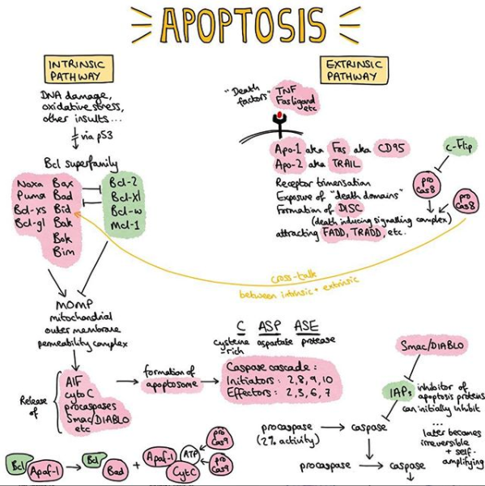](https://www.instagram.com/p/B9tnFdPAvJf/?utm_source=ig_web_copy_link)

## Mechanisms of radiation-induced cell death

|  |
| --- |
| Molecular Mechanisms of Radiation-Induced Cancer Cell Death: A Primer [[Sia FCDB '20](https://www.ncbi.nlm.nih.gov/pubmed/32117972)]  * Mitotic catastrophe (a pathway preceding cell death that happens in mitosis or as a consequence of aberrant mitotic progression) is the primary context of radiation induced death in solid cancer, although in a small subset of cancers such as heme malignancies, radiation results in immediate interphase apoptosis within hours after exposure.   **Radiation induced DNA damage is sensed by ATM and ATR** [[Maier IJMS '16](https://www.mdpi.com/1422-0067/17/1/102)]   * Figure 1: Induction of cell cycle arrest after irradiation. * Figure 2: Cell death pathways after irradiation. * Figure 3: AKT1 as a proliferation and anti-apoptotic factor. * Figure 4: Induction of DNA repair by EGFR signaling.   **Apoptosis vs. Necrosis**   * **Necrosis** (e.g. Mitotic): MCC of cell death from radiation.   + Low α/β hypothesized to die by necrosis. Exception: Lymphoma, which has decreased α/β but die by apoptosis.   + Truth is, most cell fall between apoptosis and necrosis pathways. * **Apoptosis**: Linker DNA cleaves into 185 bp, requires ATP, caspase activation, no inflammation, single cell.   + **Caspase 2, 8-10**: **Initiate**.     - 8 = Extrinsic (FAS ligand). 9 = Intrinsic (mitochondrial).     - **SMAC/Diablo** = **S**econd **M**itochondrial-derived **A**ctivator of **C**aspase, acts to inhibit XIAP.     - There can be crosstalk between extrinsic and intrinsic pathways. When low levels of caspase 8 (therefore insufficient amount of procaspase 3), then caspase 8 cleaves Bcl-2 homology 3-only protein Bid, which generates an active fragment (**tBid**) that activates the mitochondrial death pathway.   + **Caspase 3, 6, 7**: **Execute**.     - 3 = where the death pathway (8) and the mitochondrial pathway (9) meet.     - **XIAP directly inhibits** Caspase 3 as well as 7 and 9. * Bax/bak stimulate apoptosis. * Bcl-2 inhibits the action of pro-apoptotic proteins. * NF-κB is a transcription factor that interferes with pro-apoptotic signals. * Caspase 9 regulates 3 and 7.   + Caspase 7 inhibits **PARP**, which limits DNA repair ability. * Caspase 3 regulates 6.   + Caspase 6 or 3→ **Lamin A and B**, which leads to cell shrinkage.   + Caspase 3→ DFF45/ICAD→ **CAD**, which leads to DNA fragmentation.   + Caspase 3 inhibits **DNA-PKcs**, which limits DNA repair ability. |

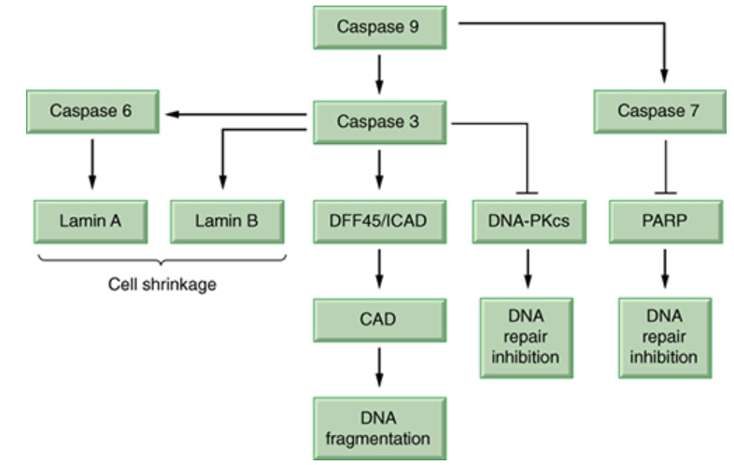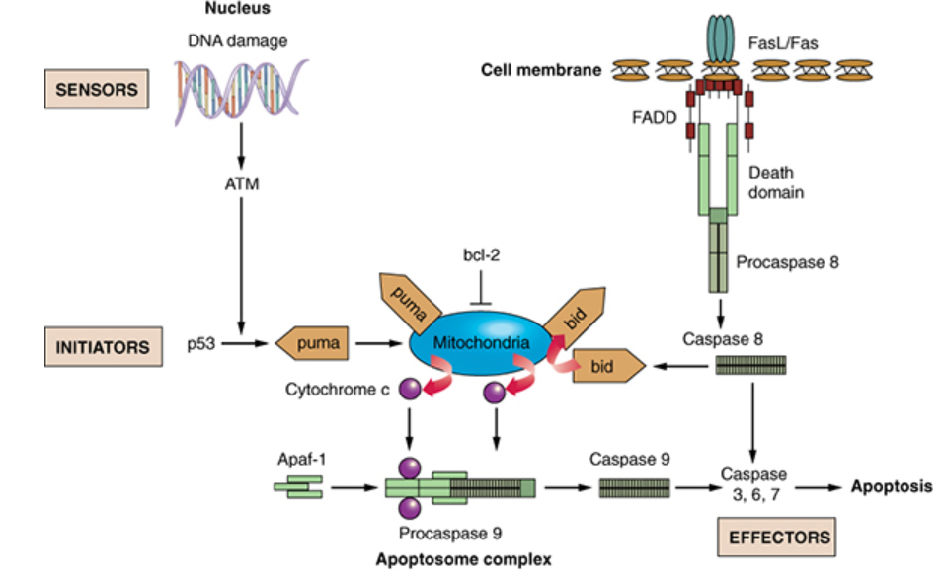

* **Mitotic catastrophe** = Most common context of cell death from radiation.
  + Radioresistant tissues have decreased α/β, and it is theorized that there is mitotic cell death.
  + Exception: Lymphoma w decreased α/β, but die by apoptosis. Truth is, most cell lines fall in between.
* **Apoptotic death** = Occurs in some normal tissues (embryonic, lymphocytes) but can occur in some cells after RT.

See Figure 2 from [[Maier IJMS '16](https://www.mdpi.com/1422-0067/17/1/102)] for more.

* + Radiosensitive tissues have increased α/β, and it is theorized that there is more apoptosis.
    - Exception: AC of GIT has increased α/β, but die by necrotic cell death.
    - Truth is, most die by both mitotic death and apoptotic death.
  + Apoptosis: important in lymphomas, essentially absent in sarcomas, and intermediate and variable in carcinomas. (No TLS in sarcomas, rare in carcinoma).
  + Intrinsic (mitochondrial) death: p53 is a central player who disrupts the balance between pro and anti-apoptotic factors. Nuclear accumulation of p53 activated pro-apoptotic BCL2 genes PUMA, BAX, and NOXA. Bax/bak stimulates apoptosis, while Bcl-XL inhibits the action of pro-apoptotic proteins. Results in the release of cytochrome C from the mitochondria and activates intrinsic pathway-specific caspase 9. See Figure 2 from [[Maier IJMS '16](https://www.mdpi.com/1422-0067/17/1/102)] for more.
  + Extrinsic death (TNF-α couples with FADD): TNF family of ligands. Eventually causes downstream activation of extrinsic-pathway specific caspase 8. See Figure 2 from [[Maier IJMS '16](https://www.mdpi.com/1422-0067/17/1/102)] for more.
    - **NF-κB** is a transcription factor that **interferes with pro-apoptotic signals**.
* **Sphingomyelinase (ASMase) death = Ceramide is created** from sphingomyelin.
  + Intracellular production of caspase cascade leads to apoptosis.
  + ATM inhibits ceramide synthase.
* The intrinsic, extrinsic and ceramide pathways converge in the activation of caspase 3 and 7.
* PTEN mutations (Cowden syndrome) lead to inhibition of apoptosis.
* **Apoptosis vs. Necrotic death**: "Orderly vs. chaos"
  + **Apoptosis**: Linker DNA cleaves into 185 bp, requires ATP, caspase activation, no inflammation, single cell.
  + **Necrosis**: Random bps, no ATP, inflammation from release of cells (ATPase breaks, cells swell, burst), mult cells.
    - Can be non-programmed by autolysis or programmed through necroptosis.
    - Ferroptosis is a type of cell death triggered by accumulation of lipid peroxides.
* **Autophagic cell death**: Portions of cytoplasm are sequestered into autophagosomes, which fuse with lysosomes, leading to degradation of proteins and organelles.
* **Cellular senescenc**e: programmed cellular stress response due to accumulation of damage to a cell resulting in irreversible cell arrest.
  + Cells can still produce cytokines and proteins. May result after loss of telomeres.
  + Telomere: TTAGGG repeats which are shortened after each cell division. After ~40-60 somatic cell divisions, telomeres become so shortened that cells cannot further divide and undergo senescence (Hayflick limit). Telomerase is a reverse transcriptase that adds telomere repeat sequence to the 3' end of telomeres to offset telomere shortening, but is turned off in most somatic human cells. Virtually all cancers must require the ability to maintain telomeres, either through expression of telomerase (90%) or through an alternative mechanism (ALT) that involves recombination.
* Three types of RT damage: LD, PLD, SLD. PLD is influenced by the environment. Delay mitosis, then PLD→ SLD.
  + SLD can be repaired in hours unless additional SLD is accrued. Exemplified by increased survival for say 2 Gy QD vs. 1 Gy BID at least 6 hours apart (E.g. split dose experiment).

## Molecular Techniques in Radiobiology

* Vectors
  + **Plasmids** (10k BP): Simplest bacterial vectors. Circular DNA molecules independent of host chromosome.
  + **Bacteriophage λ** (24k BP): Bacterial viruses.
  + **Cosmids** (55k BP): Lambda bacteriophages that have deleted the majority of the phage DNA>
  + **Yeast artificial chromosome** - YAC (200k BP):
  + **Bacterial artificial chromosomes** - BAC (300k BP):

## The cell cycle and DNA repair

|  |
| --- |
| Cyclins and Kinases *"DAB 411" for all cycles, or "DEA 421" for G1/S advancement.*  P21, wee1 and myt kinase inhibit G1 to M transition. P21 encourages M to G1 transition.   * **G1/S phase**: CC**D** and CDK **4**/6. Inhibited by p53/p14ARF and p21/p16INK4a.  Activated later: CCE/A and CDK 2. * **S/G2 phase**: CC**A** and CDK 2/**1**. Inhibited by p21. * **G2/M phase**: CC**B**/A and CDK **1**. Inhibited by p21, Chk2. * M to G1 transition: Encouraged by p21. |

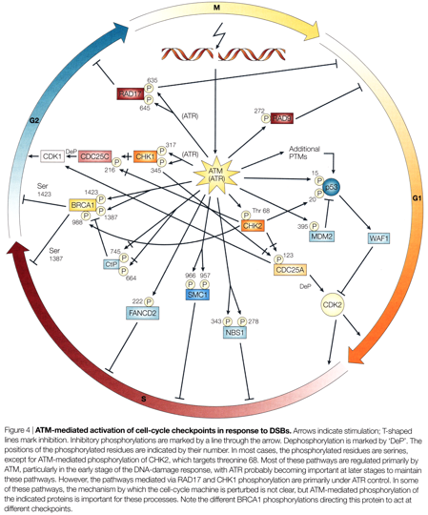

|  |
| --- |
| Checkpoint Pathways Crappy mnemonics: "ARF! I see p53" (p19ARF). p21 is like p16INK4a (CDK4/6), and "The CDC better Chk itself".   * ATM is present as dimer until damage occurs, then **autoP'lates on residue Ser1981**→ P'lates P53, MDM2, Chk2, and NBS. * **G1/S checkpoint**:   + **p53**/**MDM2**→ **p53**→ **p21⊣** CCD/E-CDK4/6→ Rb→ **G1 arrest**. *P21 serves to inhibit CDK4/6.*   + **Chk2⊣** Cdc25A→ CDK2-CCE/A→ CDC45→ **Origin arrest**. *Chk2 serves to inhibit Cdc25A.* * **S phase checkpoint**: MRE11/Rad50/**NBS**→ SMC/?→ **Intra S-phase arrest**. * **G2/M checkpoint**: Cdc25C→ CDK1/CCB→ **G2 arrest**.   + Chk2 inhibits CDC25C. Chk1 inhibits CDC25A/C.   + Wee1 inhibits CCB/cdc2 complex.   + p21 inhibits CDK1. * **All 3 checkpoints**: Wee1, myt kinase and p21. "Wee, my kinase just turned 21" |

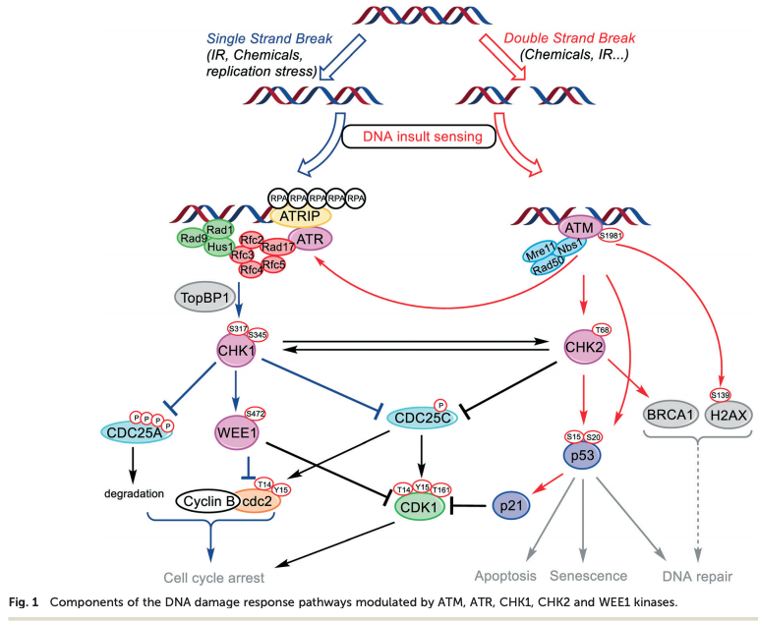

* **Rb point mutation**. **Restricts G1→ S transition**.
  + Arrest in G1: Hypo-P Rb binds and sequesters E2F.
  + **Advancing from G1→ S**: Cyclin D/C phosphorylates Rb, **E2F is released** and G1 progresses to S for LDR.
    - E7 from HPV inhibits Rb function, which releases E2F. p16 is upregulated as a result.
* **P21**: Tumor suppressor. CDK inhibitor for many cyclin/CDK complexes. Positively regulated by p53, and arrests in G1.

See figure 1 from [[Maier IJMS '16](https://www.mdpi.com/1422-0067/17/1/102)] for more.

* + P53 leads to transcription of p21.
  + Binds to CDK 4/6, inhibiting cyclin D-CDK 4/6 complex formation and CDK 4/6 P-lation of Rb family members.
* **ATM, ATR and DNA-PKcs** are members of the PIKK family which are activated by DNA DSBs, and function as kinases that regulate DNA repair and cell cycle proteins.

See figure 1 from [[Maier IJMS '16](https://www.mdpi.com/1422-0067/17/1/102)] for more.

* + Usually ATM, unless the damage is at replication fork, when it would be ATR (late G2).
  + ATM also inhibits ceramide synthase, which limits the sphingomyelinase (ASMase) pathway from causing apoptosis.
  + Both p53 and NF-κB are activated after ionizing RT in an ATM-dependent manner.
    - NF-κB is a central TF in the immune system and exhibits pro-survival effects.
  + Gamma-H2AX is P'lated within minutes, and this is triggered by ATM.
  + C-abl will be activated by DNA-PKCs and ATM, which activates YAP which is pro-apoptotic.
  + CREB will be activated by ATM, which expresses pro-survival proteins.
* **Dose-rate effect**: **Repair of SLD that occurs during RT at LDR**.
  + **Applies for 0.1-1Gy/min rates**. Above 1 Gy/min, no further dose rate effect.
    - **LDR is defined as 0.4-2 Gy/hr. HDR is defined as >12 Gy/hr.**
  + **Inverse dose-rate effect**: At about **0.37 Gy/h** (see LDR definition above) cells tend to become arrested in G2, avoiding LD, similar to a split-dose experiment. Many cells exhibit a prolonged G2 after irradiation - termed mitotic delay.
    - [Example](http://radiologykey.com/wp-content/uploads/2016/06/C5-FF4.gif): Survivors of first dose are in late S phase. If interval b/t doses is ~6h, cells have reassorted into G2/M. There would be no dip if cells are not rapidly dividing (e.g. nondividing or long cycle).
    - Generating synchronous cell populations: 1. Mitotic harvest or 2. HU (kills in S phase and causes G1/S block) or 3. Inverse dose-rate effect: give 0.37 Gy/h!

|  |
| --- |
| P53 Tumor suppressor. Functions in cell cycle regulation, DNA repair, and apoptosis.  See figure 1 from [[Maier IJMS '16](https://www.mdpi.com/1422-0067/17/1/102)] for more.   * In unstressed cells, p53 is Un-P'lated and tagged for ubiquitin degradation by MDM2. * In stressed cells or cells with DNA damage, p53 is P'lated usually by ATM in context of DSBs (and protected from MDM2).   + Two pathways:     - MAPK (JNK 1-3, ERK1-2, p38MAPk)→ membrane damage, oxidative stress, heat shock.     - ATM/ATR (CHK1/2)→ genome integrity checkpoint, DS-DNA damage.       * Usually ATM, unless the damage is at replication fork, when it would be ATR. * **4 transcription factor product categories**:   + **Apoptosis via BAX** (part of the BCL2 family).   See Figure 2 from [[Maier IJMS '16](https://www.mdpi.com/1422-0067/17/1/102)] for more.   * + - Regulates release of cytochrome C from mitochondria.     - Bax and p53 are req'd for some forms of DNA damage-induced apoptosis.     - **P53 also upregulates** **pro-apoptotic BH3 protein PUMA**.   + **G1 arrest via p21** (CDKN1A).   + **DNA repair** **by GADD45**.   + **Self negative regulation** **by MDM2** (p19ARF inhibits MDM2 inhibition).   See Figure 2 from [[Maier IJMS '16](https://www.mdpi.com/1422-0067/17/1/102)] for more.  See Figure 1 from [[Trino Front Pharmacol '16](https://www.frontiersin.org/articles/10.3389/fphar.2016.00491/full)] for more on the ARF and MDM2 interaction.   * + - INK4a-ARF locus codes from p16 (INK4a) which controls Rb and p19 (ARF - mice) or p14 (ARF - humans) which controls p53 via inactivating MDM2.     - If the INK4a locus knocked out, then p53 can be knocked out as there is no control of MDM2 inhibition. * P14/19ARF inhibits MDM2 mediated degradation of P53, while p16INK4a inhibits CDK4/6. Both of which result in G1 arrest. * Some viruses lead to inactivation by binding to p53, including E6 of HPV, adenovirus E1B, SV40 T Ag. |

|  |
| --- |
| NHEJ and HRR  * DNA DSBs repaired by NHEJ (chromosome, G1 but can occur any time) or HRR which uses template (chromatid, S/G2).  * End Recognition: MRE11/RAD50/NBS1 (**MRN Complex**) is involved in sensing dsDNA breaks. * **NHEJ:** Think of Ku70/80 complex, DNA PKCs, Artemis, and XRCC4/DNA Ligase IV.   + Can occur at any stage of the cell cycle. Used in **VDJ recombination** (Error prone, allows for diversity of Ab production)   + **53BP1** is an HRR inhibitor. It binds to DSBs and prevents end resection, thus promoting NHEJ.     - In S phase cells, BRCA1 is upregulated and can displace 53BP1 to promote end resection, promoting HRR.   + **End recognition by** **Ku70**/**80**, XRCC6/5 binding which recruits DNA PKCs and Artemis.   + **Recruitment of DNA PKCs**, which holds broken dsDNA ends together.   + **End processing by Artemis**, an endonuclease. **End bridging by XRCC4/DNA-LigIV** complex.  * **HRR:** Think of BRCA1, RAD51-57, BRCA2. Radioresistance in late S phase thought to be due to HRR with sister chromatid as template.   + Can only occur in S/G2 as sister homologue required. Resolution of Holliday junctions.   + **ATM**→ P'lation of **Gamma-H2AX** **which recruits MRN complex** (MRE11/RAD50/**NBS1**) and **BRCA1**.     - S-phase cells upregulate BRCA1 which can displace 53BP1 to promote end resection (promoting HRR).     - MRN is an exonuclease that allows **RAD51** to bind. BRCA2 recruited by BRCA1 to regulate RAD51.   + RAD51-57 help use sister chromatid as a template, which is stabilized by Holliday junctions.   + PALB2 (BRCA2) is associated with ovarian, pancreatic and male breast cancers [[Yang JCO '19](https://www.ncbi.nlm.nih.gov/pubmed/31841383)].   + Theta Mediated End Joining (TMEJ) is an error prone pathway which utilizes PARP1, MRE11, Rad50, and polϴ. There is promise that [polϴ inhibition] may be the new [PARPi].  * **ATM** is present as dimer until damage occurs, then **ATM autoP'lates on residue Ser1981 and P'lates P53**   + In stressed cells, p53 is P'lated (usually by ATM) in context of DSBs and protected from MDM2.   + Usually ATM, unless the damage is at replication fork, when it would be ATR.   + Gamma-H2AX is P'lated within minutes, and this is triggered by ATM.   + Most DSBs (80-90%) repaired within 1-2 hours. Remaining DSBs may take many hours to repair. Some DSBs are much more difficult to repair if multiply damaged or within heterochromatin, and are repaired by HRR.   **BER, NER and MMR**   * **BER**: Not an important contributor to radiosensitivity except in XRCC1 deficiency (Polβ, **XRCC1**, etc).   + **Short-patch BER**: Includes a glycosylase, AP endonuclease (**creating a SSB**), PNKP and polβ, DNA ligase III, **XRCC1**.   + **Long patch BER** (2-10 bases): RFC, PCNA, polβ/polδ/polε, FEN1 and DNA ligase I.   + **SSB repair**: Utilizes **XRCC1** and **PARP**. Considered a part of BER, as it uses the same intermediary. * **NER**: Removes bulky DNA adducts, such as pyrimidine dimers (Think: polδ, **XP** = **Xeroderma pigmentosum**, **CS = Cockayne**). NER addresses bulky lesions e.g. thymidine dimers from UV light (UV → TT dimers (pyrimidine)).   DNA cross-link repair is performed by a combination of NER and HRR.   * + NER is generally not considered important in radiosensitivity, but it is associated with hypersensitivity to UV radiation (e.g. Xeroderma pigmentosum).   + **Global genome repair** (GG-NER): XPC-XPE complexes recruit NER proteins.   + **Transcription coupled repair** (TC-NER): Stalled RNAP I/II and CSA/CSB recruit NER proteins.   RNAPIIi (Lurbinectedin) may have an ORR > 50% in BRCAmt breast cancer [QS](http://www.quadshotnews.com/2018/09/hyper-loop.html), just like [PARPi].   * + NER proteins: TFIIH complex binds to XPA/RPA. XPG and XPF-EFCC1 cut at 3' and 5' ends, release 24-32 oligomer. The remaining gap is filled by polδ/polε which is aided by RFC, PCNA. * **MMR**: Lynch syndrome most commonly MMR germline mutations in **MLH1**/**MSH2**, less common MSH6, PMS1/2.   Involves MSH2-MSH6, MSH2-MSH3 or MLH1-PMS2 and MLH-PMS1 or MLH1-MLH3 and EX01, RFC, PCNA and polδ/polε.   * + Loss of MLH1/PMS2 protein expression requires analysis for BRAF V600E or MLH1 Me'd to rule out sporadic.   + BRAF V600E somatic mutations rule out genetic syndromes. |

[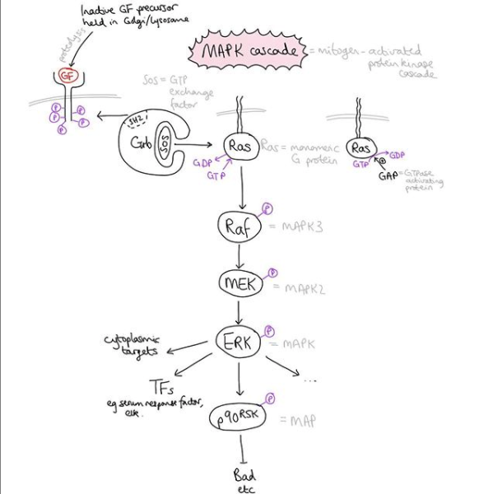](https://www.instagram.com/p/B8cLggug3pS/?utm_source=ig_web_copy_link)

[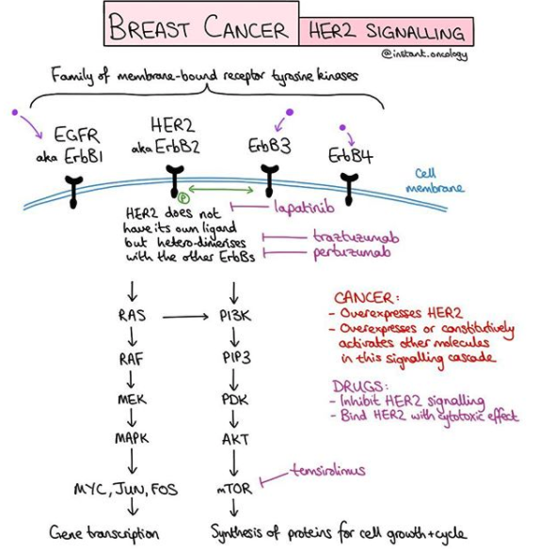](https://www.instagram.com/p/CANkWK9ATXU/?utm_source=ig_web_copy_link)

## 

## Cancer Biology

* 3 primary gene types that are mutated in cancer:
  + Oncogenes (gain of function) - 1 hit model.
  + Tumor suppressor genes (loss of function) - 2 hit model.
  + DNA stability genes (loss of function).
* Oncogenes are AD, 1 hit model.
  + Typically involved in signal transduction (eg. growth factors, GF receptors, transcription factors etc)
  + 1st oncogene = Rous sarcoma virus (SRC) from chicken sarcoma. Codes for constitutively active TK.
  + **Mechanisms**
    - **Gene amplification**: HER2, EGFR, c-myc in SCLC, n-myc in neuroblastoma.
    - **Point mutation**: Common in ras and ret family.
    - **Translocations**: Common in myc and bcr-abl.
    - **Chromosomal rearrangement**: Fusion, translocation (e.g. c-myc in Burkitt's), upregulation by active promoter.
  + **Ras family**
    - **Raf/MEK/Erk** leads to cell growth, activation of CCD1.
    - RalGDS inhibits apoptosis through Jun kinase/stress kinase JNK/SEK pathway.

* + - **PI3K**/**Akt** is a critical pathway which is exploited by cancer cells to achieve survival.

See Figure 3 from [[Maier IJMS '16](https://www.mdpi.com/1422-0067/17/1/102)] or Figure 1 from [[Vidotto BJC '20](https://www.ncbi.nlm.nih.gov/pubmed/32327707)] for more.

* + - * PTEN normally regulates several mechanisms that maintain genome stability in the nucleus, so PTEN-deficient tumors are associated with high rates of chromosome rearrangements that are usually associated with increased mutational load. However, PTEN deficiency is also associated with impaired activation of the type I IFN and NF-κB pathway which could be highly favorable for tumor progression due to an immunosuppressed tumor microenvironment.
      * PI3K P'lates inositol hydroxyls, leading to PIP2 and PIP3 production. PIP3 then tethers and activates Akt/PKB molecule which ultimately inhibits cell apoptosis.
      * Negative regulation of this pathway is by **PTEN**, which un-p'lates the active PIP3 producing inactive PIP2.

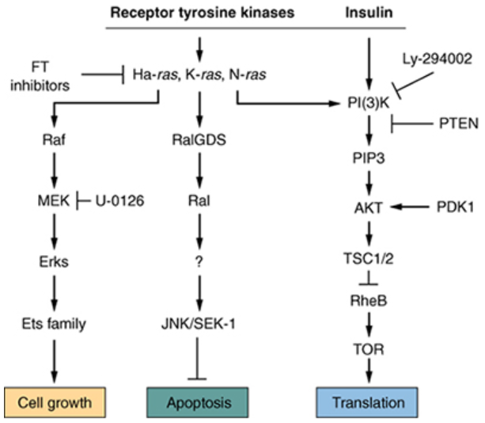

[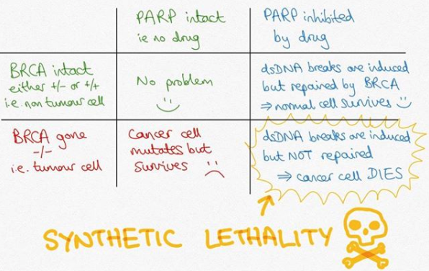](https://www.instagram.com/p/B7WJQxHJXMb/?utm_source=ig_web_copy_link)

### PARP inhibitors

TBL[QS](http://www.quadshotnews.com/2017/08/parpi-n-bottles.html): To grossly oversimplify (you're welcome), PARP repairs minor but frequent DNA damage. And if PARP doesn't fix things, the big guns (homologous recombination) typically pick up the slack. But, if homologous recombination also doesn't work (as in this case of a BRCA mutation), all those tiny little problems become big problems. Looks like BRCAmt+ breast cancer's got 99 problems...and PARP inhibition just became a big one.

* Olaparib, Velaparib, Talazoparib, Niraparib.
* PARPi requires [[BRCA mutation](https://docs.google.com/document/d/1sWQwqcSH23B30CKCVOaQ2kb4D4qES6YfPqmgJYR5rnY/edit#bookmark=id.3aqx4kfnqf7b)] or homologous recombination deficiency for synergistic effect. Without faulty DS-DNA repair such as in setting of BRCA mutation, then PARPi is not effective in and of itself.
  + See Hall and Giaccia, p496, Figure 27.4 for more on PARPi and the concept of **synthetic lethality**.
* PARP-1 plays an essential role in recruiting XRCC1. Inhibition of PARP results in decreased BER activity and accumulation of SSBs that will result in collapse of replication forks in S phase and generation of DSDNA breaks. This becomes a huge issue for BRCA-1 mutants, who are very bad at repairing DSDNA breaks.
* Many of the initial trials investigating PARPi did not appropriately select for patients with faulty DS-DNA repair, such as patients with [BRCA], [RAD51-57], [ATM], CDK12, or RAD50/[MRN Complex] mutations, for example. Newer trials have realized this and have only included patients with DNA Damage Repair alterations (DDR) such as the [[TOPARP-B](https://docs.google.com/document/d/1j15zXLBPWwqty60Slm2jnHEiqaoT2iw5Gapp4iMWJsw/edit#bookmark=id.wtll9voqrg01) [QS](http://www.quadshotnews.com/2019/12/descend-into-parpicular.html)] trial in metastatic CRPC which demonstrated a > 50% ORR, the [[MDACC](https://docs.google.com/document/d/1sWQwqcSH23B30CKCVOaQ2kb4D4qES6YfPqmgJYR5rnY/edit#bookmark=id.dg87gckapl4l) [QS](http://www.quadshotnews.com/2019/09/darkness.html)] phase II trial of neoadjuvant PARPi for BRCA-mutated TNBC demonstrating > 50% pCR after *single agent* PARPi (!), and the [[OlympiAD](https://docs.google.com/document/d/1sWQwqcSH23B30CKCVOaQ2kb4D4qES6YfPqmgJYR5rnY/edit#bookmark=id.yllgbseuou14) [QS](http://www.quadshotnews.com/2017/08/parpi-n-bottles.html), [EMBRACA](https://docs.google.com/document/d/1sWQwqcSH23B30CKCVOaQ2kb4D4qES6YfPqmgJYR5rnY/edit#bookmark=id.4ld7z2t6ct75) [QS](http://www.quadshotnews.com/2018/08/parping-back.html)] trials for metastatic breast cancer which demonstrated > 50% ORR, and the [[POLO](https://docs.google.com/document/d/13NEZCS6s13MVLixabbO2vjY73zHxJ37qE16gBbApSdY/edit#bookmark=id.vwryucsik10x) [QS](http://www.quadshotnews.com/2019/06/polo.html)] trial for pancreatic cancer which demonstrated >50% ORR. Although the response rate is favorable, the median progression free survival for single-agent PARPi is only around six months, suggesting the cell signaling cascade is just as complex as we thought it was. Beam on, and beam up the dominant mets, Scotty.
* Use caution when utilizing PARPi in combination with radiotherapy [QS](http://www.quadshotnews.com/2018/03/curiouser-and-curiouser.html) [[Jagsi JCO '18](https://ascopubs.org/doi/10.1200/JCO.2017.77.2665)].

* I want it Theta way [QS](http://www.quadshotnews.com/2019/09/i-want-it-theta-way.html): Cells with HRR deficiencies (e.g. BRCA-mutants) rely heavily on other, more error-prone, methods of DNA repair such as the one mediated by polymerase theta (polϴ). Novel targeted CRISPR screening revealed 140 additional genes, that, when lost, also make a cell heavily reliant on (aka "addicted to") this error prone polϴ pathway. Not only that, but 30% of breast cancers in The Cancer Genome Atlas harbored these polϴ addicted genes. In other words, polϴ inhibition may be the new PARPi [[Feng Nat Commun '19](https://www.nature.com/articles/s41467-019-12234-1)].

### CDK 4/6 inhibitors and PI3K inhibitors

See more on the [PI3K/Akt] pathway. It is a pathway which cancer cells frequently exploit to achieve survival. PTEN negatively regulates it.

* Palbociclib (CDK 4/6), ribociclib (CDK 4/6), Abemaciclib (CDK 4/6).
* Alpelisib (PI3Ki), Capivasertib (AKTi).
* As many as 40% of women with ER+, HER2- breast cancer harbor [PIK3CA] activating mutations.
* The PI3K/AKT signaling pathway is frequently activated in TNBC.
* PIK3CA mutations are a common mechanism of CDK 4/6 inhibition, meaning these drugs can have complementary roles.
* CDK4/6 inhibitors have demonstrated an overall survival benefit in HR(+), HER2(-) breast cancer and also can delay the time to chemotherapy initiation [[MONALEESA-3](https://docs.google.com/document/d/1sWQwqcSH23B30CKCVOaQ2kb4D4qES6YfPqmgJYR5rnY/edit#bookmark=id.5fnradf3m15f) [QS](http://www.quadshotnews.com/2019/12/ribocop.html)/ [7](https://docs.google.com/document/d/1sWQwqcSH23B30CKCVOaQ2kb4D4qES6YfPqmgJYR5rnY/edit#bookmark=id.vh2y6b7d5egc) [QS](http://www.quadshotnews.com/2019/06/7th-heaven.html), [MONARCH-2](https://docs.google.com/document/d/1sWQwqcSH23B30CKCVOaQ2kb4D4qES6YfPqmgJYR5rnY/edit#bookmark=id.cyb65gw0iwva) [QS](http://www.quadshotnews.com/2019/10/honest-abe.html)].
* PI3K inhibitors improve PFS when added to endocrine therapy for HR(+), HER2(-) breast cancer [[SOLAR-1](https://docs.google.com/document/d/1sWQwqcSH23B30CKCVOaQ2kb4D4qES6YfPqmgJYR5rnY/edit#bookmark=id.m0yp1nbwdm2y) [QS](http://www.quadshotnews.com/2019/05/take-your-pi3k.html)].
* AKT inhibitors (part of the PI3K pathway) improved OS when added to paclitaxel for untreated metastatic TNBC [[PAKT](https://docs.google.com/document/d/1sWQwqcSH23B30CKCVOaQ2kb4D4qES6YfPqmgJYR5rnY/edit#bookmark=id.dk2l4nygpqwp)].

**Roles of Cytokines and Radioprotective Cytokines**

* **bFGF**: Increases growth of endothelial cells, **protects** against microvascular damage, reduces late effects.
* **PDGF**: Increases damage to the vasculature.
* **TGF-β**: Increases inflammation (pneumonitis). Requires two different signals for transduction.
* **TNF**: Inflammation, cytotoxic, regulated by PKC pathway. May cause septic shock if given by IV.
  + **NF-κB** is a transcription factor that **interferes with pro-apoptotic signals**.
  + Pro-apoptosis: TNF-α couples with FADD with damage→ initiator caspases 8-10.  
    This may be countered by TNF pathway, with activation of NF-κB by TRADD and TRAF adapters.
* **IL-1**: Fever, inflammation.
* **IFN**: Inhibits cell proliferation in general, but can cause immune cell activation.
* **IL-6**: Potent pro-inflammatory cytokine.
* While there are some cytokines who are restorative, many are also sensitizing as well.
  + SCF, bFGF, IL-3 / 4, and IL-11 are protective or restorative without sensitization.
* G-CSF is important for restoration.
  + Note: SCF has been found to be protective of intestinal cells.

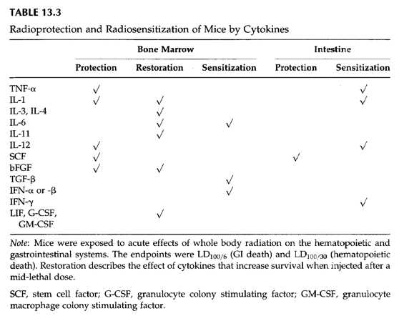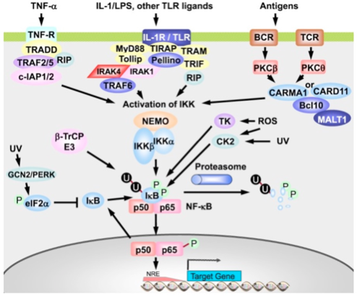

|  |  |  |  |  |
| --- | --- | --- | --- | --- |
| **Transcription Factor** | **Cell Type** | **Dose Range (Gy)** | **Target Genes** | **Notes** |
| **p53** | Epithelial and lymphocytic cancer cells | 0.2-20 | >100 known genes, growth arrest and apoptosis |  |
| **NF-κB** | Epithelial and lymphocytic cancer cells | 0.5-20 | Inflammatory **cytokines** ± regulation of radiosensitivity |  |
| **AP-1**  FOS and JUN family | Epithelial and lymphocytic cancer cells, keratinocytes | 2-20 | **Cytokines**, in collaboration with other TFs. | Activated by ROS and JNK after radiation damage. |
| **Egr-1** | Normal and cancer lymphocytic, some epithelial cancer cells | 4-20 | Growth factors (**bFGF**, **PDGF**, **cytokines** TNF-α (binds to EGFR-R), IL-1) | Pro-apoptotic after RT via TNF-α. |
| **Sp1 (RCPs)** | Melanoma, H&N SqCC, cerebral cortex (rat) | 0.1-10 |  | Can act pro-apoptotic by inducing p53 or pro-survival by inducing DNA repair. |

FOS and JUN family are associated with ERK/JNK/p38.

* **Transcription Factors in the Cellular Response to Charged Particle Exposure** [[Hellweg Front Onc '16](https://www.frontiersin.org/articles/10.3389/fonc.2016.00061/full)]:

Triggering of complex response pathways to ionizing RT converges in the activation of transcription factors, such as p53, nuclear factor κB (NF-κB), nuclear erythroid-derived 2-related factor (Nrf2), and cAMP response element binding protein (CREB).

* + Depending on the degree of ionizing damage and tissue, p53 may induce apoptosis or cell cycle arrest.
  + **Both p53 and NF-κB are activated after ionizing RT in an ATM-dependent manner**.
  + **NF-κB** is a central transcription factor in the immune system and exhibits pro-survival effects.
    - It is strongly dependent on charged particles LET, with maximal activation in the range of 90-300 keV/μm.
  + **AP-1** controls proliferation, senescence, differentiation and apoptosis.
  + **Nrf2** can induce cellular antioxidant defense systems.
  + **CREB** might also be involved in survival responses.
  + **Activation of Transcription Factors CREB, AP-1, SP1, p73, and YAP upon irradiation can activate PKA/PKB pathway along with ERK/MAPK in the cytoplasm**.
* Tumor suppressor genes - Most are capitalized (e.g. Rb, BRCA1/2, APC, PTEN, WT1/2), exceptions include p53, p16.

[**StatPearls: Tumor-Suppressor Genes**](https://www.ncbi.nlm.nih.gov/books/NBK532243/) *Last Update: 11/15/2018.*

* Retinoblastoma (Rb): The first TSG discovered. At risk for childhood Retinoblastoma, also osteosarcoma.
  + Rb normally functions to prevent cells from entering the S phase of the cell cycle. It binds to E2F, inhibiting function as a transcription factor. This blocks transcription of genes necessary for DNA replication, so the cell remains in G1.
* Li-Fraumeni (p53): known as the "guardian of the genome" as it can identify DNA damage, halt cell cycle progression to allow for repair, and to induce apoptosis when repair is not possible.
  + Loss of p53 causes the cells to not care about DNA damage and to progress through the cell cycle, avoiding apoptosis. Like Rb, the p53 protein prevents the cell from entering the S phase. It does so by inhibiting CDK4 via transcription of p21.
  + It can also induce apoptosis by activating BAX and by inhibiting bcl2 which stimulates the release of cytochrome c from the mitochondria. Cytochrome c activates caspases within the cell responsible for eventual degradation.
* Cowden syndrome (**PTEN**): Multiple hamartoma syndrome.
  + Negatively regulates the PI3K-AKT and target of mTOR signaling pathways, which are vital for cell proliferation, cell cycle progression, and apoptosis. The PTEN protein also functions to keep migration, adhesion, and angiogenesis in check.
* E-cadherin, NF2: Scwannoma, meningioma.
  + Contact inhibition. E-cadherin regulates contact inhibition by binding to a key component of the WNT signaling pathway, β-catenin. This binding prevents E-catenin from entering the nucleus of the cell, stopping it from activating transcription of pro-growth target genes. Overall, this regulates morphology and organization of epithelial cell linings. Another TSG, *NF2*, encodes neurofibromin-2 (Merlin), which acts downstream of E-cadherin to assist with contact inhibition.
* BRCA 1, BRCA 2, PARP-1
  + BRCA1 and 2 are TSGs that are involved in the repair of DNA DSBs through the HRR pathway. PARP-1 encodes a protein that assists with SSBs of the DNA. Aberrations of these genes lead to replication of faulty DNA.
* Familial adenomatous polyposis (APC): Colon, stomach, intestine.
  + APC is a TSG that encodes a suppressor protein that blocks the Wnt signaling pathway, which functions to enhance axis patterning of cells during embryogenesis, cell migration, and cell proliferation. The APC protein is also involved in apoptosis.

**Cancer predisposition genes**

* Familial Wilms Tumor (WT1)
* NF1: Neurofibroma, sarcoma.
* Gorlin syndrome (PTCH): Basal cell carcinoma.

[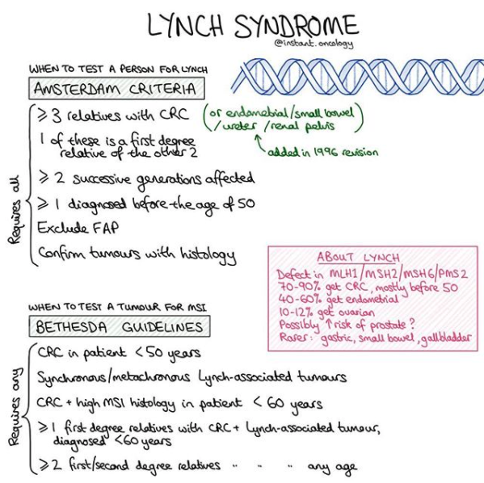](https://www.instagram.com/p/B_5ABiJgxDc/?utm_source=ig_web_copy_link)

## 

## Hereditary DNA repair syndromes

* **Megamouse experiment**: Fewer mutations result with low dose RT, female oocytes are exquisitely sensitive to RT and therefore only radiation-induced heritable data came from males (Conception 2 months after irradiation seems adequate for males, though 6 months recommended for humans).
* **Li-Fraumeni** (p53) AD. Mutations in TP53 and associated with mutations in CHEK2. Increased risk of sarcoma and cancers of the breast, brain, and adrenals.
* **Lynch syndrome**: AD. MMR germline mutations in MLH1 and MSH2, less common MSH6, PMS1/2 or EPCAM. Tested by IHC for MMR protein expression or PCR analysis for MSI. 15% of sporadic CRC have MSI resulting from hypermethylation of MLH1 gene promoter.
  + Loss of MLH1/PMS2 protein expression requires analysis for BRAF V600E or MLH1 Me'd to rule out sporadic.
  + BRAF V600E somatic mutations rule out genetic syndromes.
* **BRCA1/2**: AD. Results in defects in HRR and an increased risk of breast, ovarian, and other cancers.
  + Primarily DNA caretaker genes, moderating DSB repairs. Also some TS function (BRCA1 can activate p53 w DNA dmg)

**Sensitivity to ionizing radiation**

* **Athabascan SCID** (SCIDA): AR. Caused by mutations in DCLRE1C (Artemis), which results in NHEJ defects, radiosensitivity, and immunodeficiency (absence of T and B cells).
  + SCID: Mutation in DNA-PKcs gene ∴ NHEJ sucks. Similar to animals that lack Ku70/80 function.
* **ATM**: AR. 1/100 carriers, 1/40,000 affected. Loss of ATM protein kinase function. Results in radiosensitivity, progressive CBL ataxia, immunodeficiency, telangiectasias (red eyes), genome instability, and high incidence of cancers. 11q22-23.
* **ATLD**: AR, due to mutations in MRE11, which results in radiosensitivity (MRE11 is required for activation of ATM), progressive CBL ataxia, and genome instability.
* **NBS**: AR. Severe DD, microcephaly, facial dysmorphism, immunodeficiency. Without nibrin, MRN complex cannot be transported to the nucleus to repair DNA. NBS1 on 8q21.
  + AT, Nijmegan breakage syndrome - Think: Can't "put the brakes" on S-phase to repair DS-DNA.
* **Seckel syndrome**: AR, caused by hypomorphic mutations in ATR gene. Results in microcephaly and growth and development delay.   
  Not radiosensitive because cells still possess some ATR activity.

**Sensitivity to Cross-linking agents**: MMC, bleomycin.

* **Fanconi anemia**: AR (majority) and X-linked recessive. 6-7 yo. Dx based on response to DNA-Xlinking agents (MMC), FA genes interact with BRCA and others to repair DNA interstrand crosslinks. Increased cancer risk (AML), chromosomal aberrations (quadriradial chromosomes), bone marrow failure, cafe au lait, short stature, issues with thumbs, radii, hands, head (micro/hydro).
  + Fanconi's anemia: Poor at HRR, spontaneous chromosomal instability, sensitivity to interstrand DNA crosslinks.
* Other inherited bone marrow failure syndromes:
  + Diamond-blackfan anemia: 3 mo dx. Double jointed thumbs. Elevated adenosine deaminase. Known mutations of ribosomal subunits. Low risk for cancer.
  + Shwachman-Diamond syndrome: Dx at 2 weeks. Aplastic anemia ~20% by year 3. Elevated risk for cancer in 30s. Thorax abnormalities.
  + Dyskeratosis congenita: Previously associated dermatological phenotype with hematologic problems. M:F 3:1. 75% have classic traits of dystrophic nails, lacy reticular pigmentation and oral leukoplakia. Can see lacrimal duct stenosis, DD, poor dentition, early gray hair. Microcerebellum. Risk of severe aplastic anemia.

**Sensitivity to UV radiation / NER pathway**

* **Cockayne syndrome**: AR. Mutations in CSA (ERCC8) or CSB (ERCC6) genes. Results in TC-NER defects, microcephaly, neurodegeneration, FTT, growth defects, sensitivity to UV radiation, premature aging.
* **Xeroderma pigmentosum**: AR. Mutations in genes that code for NER proteins (DDB2, ERCC2-5, POLH, XPA/C). Extreme sensitivity to UV radiation and increased risk of skin cancers, including melanoma.
* **Trichothiodystrophy**: Defects in NER pathway. S-deficient brittle hair, some have photosensitivity/neurologic problems.

**Issues with helicase**

* **Bloom syndrome**: AR. Mutated BLM helicase gene. Results in HRR defects, high incidence of cancers, sun-exposed skin rash, dwarfism, hypogonadism, immunodeficiency, and increased sister chromatid exchanges.
* **Werner syndrome**: AR. Mutations in WRN helicase gene, resulting in HRR defects, premature aging (progeria) and increased cancer risk.
* **Rothmund-Thomson syndrome** (RTS): AR. Mutations in RECQL4 helicase, resulting in HRR defects, poikiloderma, photosensitivity, juvenile cataracts, congenital bone defects, hair growth issues, increased risk of osteosarcomas.

**Association between polymorphisms in DNA damage repair genes and RT induced Early Adverse Skin Reactions** [[Lee IJROBP '20](https://www.ncbi.nlm.nih.gov/pubmed/32007367)]:

* ATM, CHEK1, ERCC2, RAD51C, TGFB1 were significantly associated with RT-induced early adverse skin reactions.

## Common DNA Damage Assays

|  |
| --- |
| **Best assay to detect DNA damage post-exposure**   * DS-DNA breaks→ Gamma-H2AX focus formation. *Dose range > 0.05 Gy.* Comet assay > 1 Gy. PGE > 5-10 Gy. * 1h → PFGE. *Dose range 5-10 Gy.* * 1w → Dicentric/ring chromosomes (Classical karyotyping). *Dose range > 0.25 Gy.* * 1y → FISH (symmetric translocations). *Dose range > 1 Gy.*   + Complicated by translocations present before irradiation. |

* **Intrinsic radiosensitivity**: **Clonogenic assays**.
  + Takes a long time to determine sensitivity, especially in vivo. It is not popular, time consuming, requires expertise, and it is hard to grow tumor cells in biopsy sample.
  + *In vitro* clonogenic survival assay: Gold standard. Cells plated in plastic dishes, exposed to agent(s) of interest, and allowed to grow in colonies for several days to weeks.
    - As a control, untreated cells are plated to determine the plating efficiency (# colonies counted/cells plated X 100%).
    - Surviving fraction = # colonies counted / [cells seeded x plating efficiency/100]
  + *In vivo* clonogenic assays include skin colony assay, jejunal crypt stem cell assay, testes stem cell assay, bone marrow stem cell assay, and kidney tubules assay.
* **Measuring DNA DSB**
  + **Single-cell electrophoresis** (**Comet assay**): Embedded in agarose gel, lysed by neutral buffer. No break = no migration. For SSB, use alkaline buffer. Comet's tail is migration of DNA in agarose, which is proportional to DNA damage.
    - In alkaline solution, SSD dose range > 0.05 Gy. Less sensitive for DSB - dose range > 1 Gy.
    - Comet assays can be performed on proliferating and non-proliferating cells while G2 and MN assays can only be used on proliferating cells.
  + **Radiation-induced nuclear foci assay**: **Gamma-H2AX focus formation at DNA-DSB**. Sensitive, currently favored DSB assay. Dose range > 0.05 Gy.
    - Cells/tissues incubated with antibodies against DNA damage signaling or repair proteins that localize to sites of nuclear DNA DSBs (e.g. ៵H2AX, 53BP1, ATM, RPA, RAD51, BRCA1 - see HRR above).
    - ៵H2AX foci at 24 hours after irradiation represents the residual level of unrepaired DNA DS breaks, which correlates with intrinsic radiosensitivity.
  + Research DNA assays
    - **Pulsed-field gel electrophoresis** (PGE): Embedded in agarose gel, not lysed. DNA fragments migrate.
      * Requires high radiation dose. Dose range for DSB > 5-10 Gy.
* **Chromosome aberrations in human lymphocytes**: Cytogenetic assay used as biomarker of RT exposure. Lymphocytes are obtained days to weeks after exposure to TBI and stimulated to divide with phytohemagglutinin and arrested at metaphase. The frequency of long-lived symmetric aberrations (translocations) in the lymphocytes reflects dose received. Able to detect RT exposure as low as 0.25 Gy.
  + Can measure dicentrics and rings and lymphocytes down to **0.25 Gy**, lifespan of mature lymphocyte is 1500 days (can only measure chromosome aberrations because in-vivo lymphocytes are in G0 and do not undergo synthesis or divide).

|  |  |  |  |  |
| --- | --- | --- | --- | --- |
|  | **Type of Assay** | **Method** | **Procedure** | **Comments** |
| T  U  M  O  R  C  E  L  L  A  S  S  A  Y  S | In situ tumor irradiation, in situ measure of response | **Tumor growth measurement** | Time to regrow measurements. | Growth delay increases as a function of dose. |
| **Tumor control (TCD50) assay** | TCD50 is the dose at which 50% of tumors are locally controlled. | Has the most obvious relevance to clinical radiotherapy. |
| In situ tumor irradiation, recipient or in vitro measure of response | **Limiting dilution assay** | TD50 is the number of cells required to transfer the tumor to 50% of recipients. | Requires single cell suspension. First in vivo survival curve. Uses a lot of animals. |
| **Lung colony assay** | Injects irradiated single cell suspension into animals, counting lung colonies. | Requires single cell suspension. |
| **Excision assay** | Cultures irradiated solid tumor. | Combines validity of in situ irradiation with speed and economy of in vitro endpoint assay |
| **Xenografts** | Human tumor cells implanted in immunodeficient recipient animals with response assessed by growth delay or cell survival techniques. | | Stroma of mouse origin, so no better than murine tumors in cases where vascular supply is a factor. |
| N  O  R  M  A  L  C  E  L  L  A  S  S  A  Y  S | In situ irradiation,  in situ measure of response | **Skin stem cell colonies** | Test dose given to island of skin. Nodules of regrowing skin scored later. | Range of doses is restricted by area of skin. Split doses can be used. |
| **Small intestine crypt cell stem cells** | Need at least 1 cell per crypt to kill | Single doses must be > 10 Gy, but can reconstruct survival curve from multi-fraction data. |
| **Testes stem cells** | Counts proportion of tubules containing spermatogenic epithelium. | High single doses needed, but can reconstruct survival curve from multi-fraction data. |
| **Kidney stem cells** | Number of regenerating tubules scored. | First clonal assay for a late-responding tissue. |
| In situ irradiation, recipient measure of response | **Lung colony assay** | Suspension of bone marrow cells injected into lungs of previously supra-lethally irradiated recipients. Spleen colonies counted at 9 days. | Till and McCulloch obtained first survival curve for bone marrow cells |
| **Mammary cells, thyroid cells** | Processed to single cell suspension then known number of cells are injected into inguinal or interscapular white fat pad of recipient animals. |  |

## 

## Effects of Oxygen

* Due to the short half-life of free radicals, oxygen must be present in tissue at the time of irradiation.
  + DNA radicals from direct/indirect ionization are **10-6 s**. OH- radical has a lifetime of **10-14s** (H2O+ lifetime **10-18s**)
  + **Range of OH radical is 4 nm** or twice that of dsDNA helix (**2 nm**)
* OER = (dose req'd for biological effect under anoxic conditions) / (dose req'd for same biological effect under aerobic conditions).
  + OER is 2.5-3 for low LET. It decreases when LET is above 30 keV/μM and decreases further to unity when LET ≅ 200 keV/μM.
    - OER for x-rays is 3 at high doses, and 2 at doses less than ~ 2 Gy.
    - Neutrons have an intermediate OER value ~1.6 ∴ RBE = 2.
    - OER for alpha particles approach unity.
  + At high LET, OER approaches 1 as most damage produced is direct, which is not oxygen dependent.
* Relative OER radiosensitivity occurs mostly between 0 - 30 mmHg.
  + Half of max OER effect noted at **0.5% or 3mm Hg**. ~2% oxygen will have maximum radiosensitization.
  + Maximum OER effect is saturated at 20-40 mmHg.
  + Most tissues are 5% oxygen and fully sensitized to low LET radiation.
  + Hypoxic fractions vary from 0 to 50%, with an average of about 15%.
* In animal models, there is a wide range of percentage of hypoxic cells in tumors, with an average of ~15%.
  + O2 can diffuse from arteries **~70um**. Hypoxic viable cells exist at depths 150-180um.
  + As the diameter of the necrotic area increases, viable tumor cell sheath remains essentially constant at 100-180 um.
* **HIF-1α** (**normoxic**) **is hydroxylated**→ **binds to VHL TSG**→ **ubiquitination**.
  + **Hydroxylation occurs by oxygen-dependent 4-prolyl hydroxylases** (**PHDs**).
    - PHD is the sensor of oxygen. VHL then attaches to the two hydroxyl groups and the cell is ubiquitinated.
* **HIF-1α** (**hypoxic**) **no hydroxylation**→ **stable, enters the nucleus, binds to 1β**→ **VEGF, EPO and glycolysis activation**.
  + Without oxygen, PHD does not hydroxylate HIF-α.
  + Hypoxia promotes: Genomic instability, decreases apoptotic sensitivity, increases mets potential/angiogenesis.
  + If VHL is compromised, then elevated concentrations of HIF result which has been associated with highly vascular tumors: Hemangioblastomas, RCC, pancreatic serous cystadenomas.
  + PTEN mutations have also led to PI3K/AKT/mTOR regulated HIF production.

|  |
| --- |
| **Clinical Pearl: Radioprotectors, Hypoxic cytotoxins and Radiosensitizers**  Radiosensitizing hypoxic cells   * **HBO** (Debatable)**, breathing Carbogen** (95% O2, 5% CO2)**, and Nicotinamide** (Vit B3). **ARCON** trials. * **-Azoles**: Oxygen substitutes that diffuse into poorly vascularized tissues.   + F-miso can be used to identify hypoxic cells on PET scans. * **5-Bromodeoxyuridine** (**BrdU**): Incorporated in DNA in place of thymidine to act as a radiosensitizer.   + Clinical usefulness is limited, as myelosuppression occurs at radiosensitizing concentrations.   Radioprotectors   * **Amifostine** (WR-2721): Antioxidant. Most tumors do not have Alk Phos to activate amifostine. Does not penetrate CNS.   + Can prevent CDDP-associated toxicity, reduce G3-4 neutropenia (G-CSF likely better), and decrease xerostomia (RT alone). * **Palifermin**: Used in TBI setting. Recombinant keratinocyte growth factor to reduce oral mucositis. * **Glutathione**: A sulfhydryl compound which is a radioprotector / free radical scavenger.   Hypoxic cytotoxins   * Bioreductive drugs that are reduced preferentially in hypoxic cells to cytotoxic agents. * Quinone antibiotics: **MMC**. * **Tirapazamine**: High selectivity for hypoxic cells. Mixed results. |

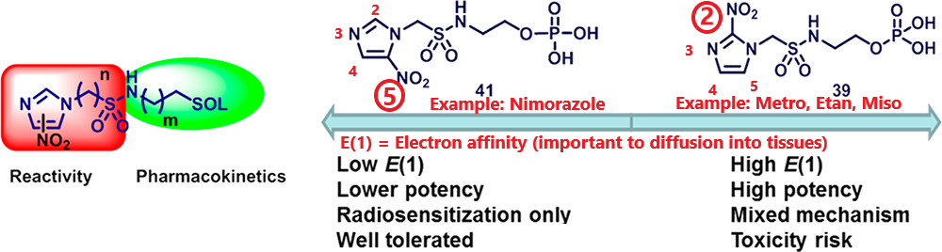

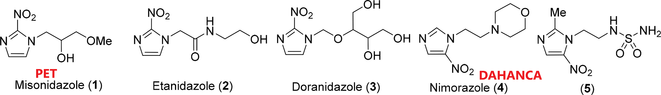

Next-Generation Hypoxic Cell Radiosensitizers: Nitroimidazole Alkyl Sulfonamides [[Bonnet JMS '18](https://pubs.acs.org/doi/10.1021/acs.jmedchem.7b01678)]: Examples of 2-Nitroimidazoles

Radiosensitizing Hypoxic Cells

* **Hyperbaric oxygen**: Subject to great deal of debate. There may be increased LC, though potentially increased late toxicity.
* **Hypoxic radiosensitizers**: Oxygen substitutes that diffuse into poorly vascularized tissues.
  + Includes metronidazole, misonidazole, etanidazole, nimorazole, nicotinamide.
  + Higher electron affinity will be more radiosensitizing. In general, 2-nitroimidazoles will have greater electron affinity than 5-nitroimidazoles (e.g. **Metronidazole** is a 2-nitroimidazole and was only briefly tried as a radiosensitizer due to high rate of peripheral neuropathy).

* + **Misonidazole**: Has a high rate of peripheral neuropathy, which limits its clinical usefulness.
    - Clinical usefulness: Marking hypoxic cells. **F-Miso can be used to identify hypoxic cells on PET scans**.

* + **Etanidazole and Nimorazole** do not have **peripheral neuropathy**.
    - Etanidazole could be given at 3x higher concentrations than Misonidazole, but trials demonstrated no benefit.
    - Nimorazole is a 5-nitroimidazole so it is less effective, but much better tolerated.
    - Nimorazole found to have significant benefit for LRC and DFS in SGL and OP in DAHANCA 5 (RT ± nimorazole).
* **Breathing Carbogen** (95% Oxygen and 5% CO2): Used as 100% oxygen can lead to vasoconstriction.
* **Nicotinamide** (Vitamin B3 analogue): Prevents transient fluctuations in blood flow that can be caused by intermittent constriction.
  + **A**ccelerated **R**adiotherapy, **C**arb**O**gen and **N**icotinamide (**ARCON**) **trials** underway at several European centers.
* **5-bromodeoxyuridine** (**BrdU**): Incorporated in DNA in place of thymidine to act as a radiosensitizer.
  + Clinical usefulness is limited, as myelosuppression occurs at radiosensitizing concentrations.
  + Used for [**Radiolabeling**](http://www.phnxflow.com/ezbrdu.html)! With propidium iodide.

Hypoxic Cytotoxins

* **Hypoxic cytotoxins**: **Bioreductive drugs** that are reduced preferentially in hypoxic cells to cytotoxic agents.

1. **Quinone antibiotics**: e.g. **MMC**.
2. Nitroaromatic compounds: Toxicity prevents research in the clinical setting.
3. Benzotriazine di-N-oxides: **Tirapazamine** demonstrates highly selective toxicity towards hypoxic cells *in vivo*/*vitro*.

* Tirapazamine may also act as an aerobic radiosensitizer before or after aerobic irradiation.
* There has only been one trial investigating tirapazamine with RT, even though it has an additive effect. Side effects on this trial include nausea and severe muscle cramping.
* There are many more trials working with tirapazamine to chemotherapy: E.g. HeadSTART, which demonstrated no differences in FFS, time to progression or QoL.

1. Dinitrobenzamide modified nitrogen mustard.
2. 2-nitroimidazole attached to dibromo-isophosphoramide (Metronidazole).

|  |
| --- |
| **ASCO Guideline:** [**Use of Chemo and RT Protectants Update**](https://www.asco.org/research-guidelines/quality-guidelines/guidelines/supportive-care-and-treatment-related-issues#/10166) *January 1, 2009*  **Dexrazoxane**: Not recommended for use in BrCa adjuvant setting, or metastatic setting w *initial* doxorubicin-based chemo. Consider in metastatic BrCa and other malignancies, for pts who rec'd > 300 mg/m2 doxorubicin who may benefit from cont'd doxorubicin.   * Recall: Lifetime dose of adriamycin is 450 mg.   **Amifostine**: Consider for prevention of CDDP-associated nephrotoxicity, reduction of G3-4 neutropenia (alternative strategies are reasonable), and to decrease acute and late xerostomia with fractionated RT alone for H&N cancer.   * Better luck next time: Protection against thrombocytopenia, CDDP neurotoxicity/ototoxicity, paclitaxel associated neuropathy, RT-associated H&N mucositis (try probiotic pills[QS](http://www.quadshotnews.com/2019/03/go-anti-mucositis.html) instead!), or esophagitis during CCRT for NSCLC.   **Palifermin**: **Recommended to decrease severe mucositis in ASCT with TBI conditioning** **regimens** (heme malignancies).   * Data insufficient to recommend for use in the non-SCT setting. |

## 

## Radioprotectors

See the Summary Box above.

* Sulfhydryls: Cysteine, amifostine.
* **Amifostine** (WR-2721): Astronauts. With alkaline phosphatase, it is converted to WR-1065.  
  Use of Amifostine for Cytoprotection during RT [[King Onc '19](https://www.ncbi.nlm.nih.gov/pubmed/31846959)]: Amifostine was FDA approved nearly 20y ago, but has yet to achieve widespread clinical use. Amifostine has largely fallen out of use with the implementation of IMRT, but the side effects of IMRT are still significant therefore the use of Amifostine needs to be re-explored in the IMRT-era.
  + Antioxidant but also may stabilize damaged DNA sites and repair mechs (works if given after RT).
  + Prodrug that is unreactive and poor penetration until it is dephosphorylated by alk phos.
    - **Most tumor cells do not have alkaline phosphatase to activate amifostine**.
  + Also protector for chemo: nephro, oto, neuro from cisplatin and hematologic from cyclophosphamide.
    - Think: Does not cross the BBB.
  + Want to give 400 mg/kg, but toxic. HTN common. Benefits at nontoxic dose of 25 mg/kg.
  + Can reduce acute and late xerostomia in phase III RCT, no documented tumor protection effect.
* **Palifermin** (keratinocyte growth factor)
  + Recombinant keratinocyte growth factor can reduce oral mucositis in pts who receive TBI.
  + Data insufficient to recommend for use in the non-SCT setting.
* **Glutathione** is an endogenous radioprotector/free radical scavenger.
  + In-vivo DNA is more resistant to radiation than free DNA: 1) presence of glutathione 2) protection w in-vivo DNA packing.

## 

## Chemotherapies from the Perspective of a Radiation Biologist

* General background
  + **Cross-linkers** (**S phase specific**): **Cisplatin**, **Cyclophosphamide**, Dacarbazine, Busulfan.
  + **Microtubules** (**G2/M**): **Paclitaxel**, **Docetaxel**.
  + Cells with fast turnover are more likely to have a large S-phase component. Agents that are most active in S-phase are relatively ineffective against cells that turn over slowly (more likely to be in G1 phase).
  + Alkylating agents or other agents that interact with macromolecular DNA may be effective against slow growing cells.
  + Side effects may be related to cells with high turnover, such as mucosal surfaces.
* Many agents fall into three categories, though many newer and most widely used agents do not fall into any of these classes.

1. **Alkylating agents**: **Cell cycle nonspecific**. Alkylates many compounds, including DNA.

* **Nitrogen mustard derivatives**: **Cyclophosphamide**, chlorambucil, melphalan.
* Ethylenimine derivatives: **Thiotepa**.
* Alkyl sulfonates: **Busulfan**.
* Triazine derivatives: Da**carbazine** (adds "da carbon" to DNA), procarbazine.
* **Nitrosoureas**: **Carmustine** (BCNU), **Lomustine** (CCNU), methyl CCNU.
  + These agents undergo biotransformation in vivo, leading to various biological effects including alkylation.
  + There is no PLD repair with nitrosoureas, whose metabolites inhibit DNA repair. *Compare to Bleomycin.*

1. **Antibiotics**: Generally **cell cycle nonspecific**. Bind directly to DNA.

* **Dactinomycin**: Intercalates with guanine residues of DNA. May inhibit DNA synthesis at higher concentrations.
* **Doxorubicin / daunorubicin**: Undergo extensive bioreduction in liver and are bound extensively in tissues.
* **Bleomycin**: Induces DNA fragmentation via free radical formation.
  + PLD repair is evident if plated immediately. *Compare to Nitrosoureas.*
  + This agent is most effective against oxygenated cells.
* **MMC**: Unlike other antibiotics, it is activated *in vivo*. It is toxic to hypoxic cells.
  + MMC undergoes bioreduction in the absence of oxygen. Think: Tirapazimine does this.

1. **Antimetabolites**: Substitution, competition to occupy catalytic sites, competition with metabolites that regulates enzymes.

* **MTX**: Folic acid antagonist, inhibiting DHF reductase, preventing formation and recycling of THF.
* **5-FU**: Analogue of thymidine (pyrimidine). Irreversibly inhibits thymidylate synthase.
  + Degradation enzymes are found in high concentrations in the gut, but not colonic carcinomas.
* **Hydroxyurea**: Inhibits ribonucleotide reductase.
* **Nucleoside analogues** (**Cytarabine**): Deoxyribose sugar is altered, inhibiting chain elongation at the 3' end.
  + This is the *only* antimetabolite that alters the sugar group of nucleosides (other antimetabolites as listed above target production of the base, cytarabine and 5-azacytidine are not thought of as antimetabolites).

1. **Not categorizable**: Platinum compounds, procarbazine, vinca alkaloids, taxanes, topoisomerase, and targetable mutations.
   * + **Inhibition of microtubule formation**: G2/M arrest.
       - **Vinca alkaloids** (VCR, Vinblastine): "Spindle poisons" from periwinkle plant.
       - **Taxanes** (Paclitaxel, Docetaxel): Paclitaxel is derived from the yew tree, while docetaxel is synthetic.
         * Potent microtubule hyper stabilizer once cell division is complete.
     + **Topoisomerase inhibitors**: S, G2/M phase.
       - Inhibit Topoisomerase I: **Irinotecan**, **topotecan** (Camptothecin analogues).
       - Inhibit Topoisomerase II: **Etoposide**, **FQs**, "Rubicins".
     + **Cisplatin** works by causing **DNA cross-linking**. It is cell cycle non-specific.

|  |
| --- |
| A note on Platinums from [[Instant.Oncology](https://www.instagram.com/p/B8rUEMnAVhw/?utm_source=ig_web_copy_link)]: Platinums are an important group of chemotherapy agents.  They work by forming covalent bonds with electrophilic atoms, especially N7 guanine and N7 adenine. Because each platinum has two arms which can form this reaction, it can form a permanent link between adjacent DNA bases, preventing strand separation for transcription and replication. When the cell attempts to read its DNA but cannot, the DNA breaks. Platinums can also react with RNA, preventing protein translation.  The mechanism by which cisplatin activates is called the Aquation Reaction: in low chloride conditions in cells, chloride ions are displaced by H2O. Thus forms the highly reactive species that reacts with DNA/proteins.  **Platinums are radio-sensitising, because radiation also works by inducing DNA breaks.**  Mechanisms of resistance:  1. Increased cellular efflux, eg cMOAT protein.  2. Increased expression of glutathione, which binds and inactivates platinums.  3. Increased expression of ERCC1-XPF (a key protein involved in nucleotide excision repair) which repairs DNA damage.  4. Loss of mismatch repair, which impairs the cell’s ability to detect DNA damage and undergo apoptosis; also makes the cell accumulate mutations faster. (This last one does not apply to oxaliplatin, due to its bulkiness. Therefore if this is the mechanism of resistance in a particular case, there will be no cross-resistance.) |

* + PLD and SLD repair and chemotherapeutic agents:
    - Significant factor in antibiotics bleomycin and doxorubicin.
    - There is no PLD repair with nitrosoureas, whose metabolites inhibit DNA repair. *Compare to Bleomycin.*
  + Oxygen effect and chemotherapeutic agents:
    - Bleomycin, procarbazine, dactinomycin and VCR are more toxic to aerated cells.
    - MMC and tirapazamine are more toxic to hypoxic cells.
    - 5-FU, MTX, CDDP, and nitrosoureas appear to be equally cytotoxic to aerated and hypoxic cells.
* Second malignancies
  + Speculation that factors that determine whether an agent is a powerful or a weak carcinogen is the number of DNA lesions required on average to kill a cell. If small, then it is a powerful cytotoxic agent and a weak carcinogen. If large, then it is a powerful carcinogenic agent.
  + Example of powerful cytotoxic agents and weak carcinogens: Radiation and Bleomycin, with number of lesions per cell per D37 of 1,000 and 150 for SSBs, and 40 and 30 for DSBs, respectively.
    - This demonstrates that RT and bleomycin are weak carcinogens because they are efficient at killing cells.
  + Example of powerful carcinogens: UV light, which generates 1 million TT dimers per D37. Also, benzopyrene, which generates 100,000 lesions for the same level of survival.

[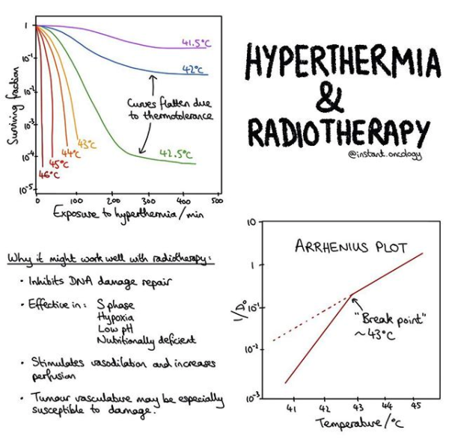](https://www.instagram.com/p/B_fyzMSAWWt/?utm_source=ig_web_copy_link)

## Effects of Hyperthermia

Cells that are most resistant to RT are most sensitive to hyperthermia (i.e., late S phase). Therefore, hyperthermia and RT could be very complementary with one another.

* Cells treated with hyperthermia undergo death by apoptosis and damage is expressed more quickly than damage from RT.
* Hyperthermia induces cellular damage, preferentially damages tumor vasculature, and increases normal tissue vessel wall permeability to there is a differential temperature increase in tumors versus tissue.
* Methods: Microwaves, RF-induced currents, ultrasound.
  + Microwaves provide good localization at shallow depths, at which low frequencies are needed.
  + Ultrasound can achieve deep heating.
* **43o C = breakpoint**.
  + This range has additive and synergistic cytotoxic effects with RT.
  + Late S phase cells that are resistant to x-rays are sensitive to heat. Cells in G1 / early S most heat resistant.
* Hypoxia does not protect cells from hyperthermia.
  + Mild hyperthermia (41 - **41.5o C**) can promote tumor oxygenation.
* **Survival curves**
  + Prolonged irradiation at 42o C (or above the breakpoint) will eventually cause vascular damage.
  + Looks similar to cell survival curve with RT, but **resistance tails** develop at lower temperatures due to thermotolerance.
  + Thermotolerance occurs *after* heating above the breakpoint.
* **Thermotolerance**: induced resistance of a tumor cell to the second fraction of heat. This coincides with increased expression of HSP.
* **Arrhenius plot**: Relationship between treatment time and temperature for a biologic isoeffect: x-axis is 1/T while y-axis is 1/D0. T is absolute temperature and D0 is the time at a given temperature to reduce the surviving fraction to 37%. There is a breakpoint at 43C in humans. Below 43C, thermotolerance can develop during heating and the heating time required must be halved and below breakpoint (higher temperature) thermotolerance can develop after heating and the heating time required must be reduced by 4-6 for each 1o C rise.
* TER (thermal enhancement ratio) = ratio of RT doses ± heat to produce the same biological effects.
  + **TER of 2-4** can be obtained in tumors and normal tissues in animals.
  + TER is between 1.15 and 1.5 in previous clinical studies.
* Lower pH and nutrient deficiency increase sensitivity to hyperthermia.
* **Outcomes for hyperthermia with CCRT in patients with cervical cancer** [[Wang IJROBP '20](https://www.ncbi.nlm.nih.gov/pubmed/32179132)]: **CCRT/B ± Hyperthermia**.
  + 373 pts. Stage IB-IV. 2009-2013.
    - Hyperthermia: Four orthogonal thermode applicators were placed in the lower abdomen centered on the uterus and cervix including pelvic drainage areas. Temperature was monitored in the vagina and rectum, and an average temperature of 40.5o C (range 39.5-41.5ºC) for 60 minutes twice a week for 6 fractions was used. It could reach the predetermined temperature after heating for more than 10 minutes.
  + 5y OS 72→ 82%.
  + 5y local RFS ~83→ 87%.
  + Acute or late toxicity was not significantly different.

## Effects of acute TBI

* Temporally acute effects:
  + **Prodromal radiation syndrome**: Timing depends on dose but can be from ~5 min to days. 20+ Gy can be severe, < 20 Gy can be variable. Includes fatigue, anorexia, N/V, cramps, salivation, apathy, listlessness, sweating, fever, headache, hypertension. If supra-lethal dose, then fever, hypotension, and immediate diarrhea.
    - Emesis after RT: None after 1 Gy TBI, most vomit if at least 2 Gy. If vomiting occurs within 2h, then the dose is at least 3 Gy.
  + **Cerebrovascular syndrome**: **50-100 Gy**. Death 10-48h after exposure. Damage to intracranial vessels. N/V, ataxia, respiratory distress, coma, seizures.
  + **Gastrointestinal syndrome**: **5-12 Gy**. Death 3-10d after exposure (typically starts at 9-10 days in humans, while 3-4 days in mice). Thought to be from death of intestinal crypt stem cells and/or apoptosis of vascular endothelial cells.
  + **Hematopoietic syndrome**: **3-8 Gy**. Peaks at 30d, continues for 60d. Sterilization of precursor cells leads to pancytopenia. After a 3 week latent period, symptoms of chills, fatigue, hemorrhages of skin, ulceration of mouth, infection, etc.
    - LD50/60: 3-4 Gy. LD50/60 with antibiotics and medical care: < 8 Gy. 8 Gy = 100% mortality.
* 0.5 Gy→ decreased lymphocytes (Apoptosis).
* LD50 for humans w/o medical intervention is 3-4 Gy.
  + Symptoms: Anorexia, N/V, easy fatigability.
* LD50 for humans with medical intervention is increased by a factor of 2 to ~8 Gy. Add perhaps 2 Gy if BMT performed.
* People with doses from 8-10 Gy may benefit from BMT. (e.g. ~8-10 Gy).
* Epilation: 3 Sv. Erythema: 6 Sv.

## Effects of Radiation on the Embryo/Fetus

* **Preimplantation** (0-9 days): 0.05-0.15 Gy prenatal death. Blastula is 128 days. All or nothing death - failure to implant or undetected death. Lowest dose required.
* **Organogenesis** (10d - 6w): **Malformations**, peak incidence of teratogenesis. Differentiating phase of cells is particularly sensitive.
  + For practical purposes, radiation doses to the fetus < 0.1 Gy do not seem to significantly increase risk of malformations.
  + Dose of > 0.1 Gy for fetus 10d-25w is considered threshold for consideration of abortion.
* **Fetal period** (6 weeks to birth): Issues with structures already formed, **growth disturbances without malformation**. Requires much higher doses to cause lethality. After 6-7 mo, the concern becomes childhood leukemia as opposed to growth disturbances.
  + Microcephaly (0-15w), MR (~40%/Sv at 8-15w, 10%/Sv at 15-25w), carcinogenesis (excess absolute risk ~6%/Gy).
    - There is about a 25 point IQ decrease per Gy, with most sensitive period for MR from 8-25w.
  + Low dose irradiation of the fetus in utero (esp last trimester) increases childhood malignancies. 10 mGy increases risk 40%, excess absolute risk is ~6% per Gy. Risk estimates are highly uncertain but not zero.
* In utero RT exposure → excess cancer risk of 6%/Gy, not all that different from A-bomb data. Primarily from RT in 3rd trimester.
* Japanese survivors: Mental retardation is most likely at 2 - 4 months, as this period is when migration of cells to site of function during formation of the brain cortex. Risk of mental retardation continue up to 6 months, though is 4x less per sievert after 4 months.

[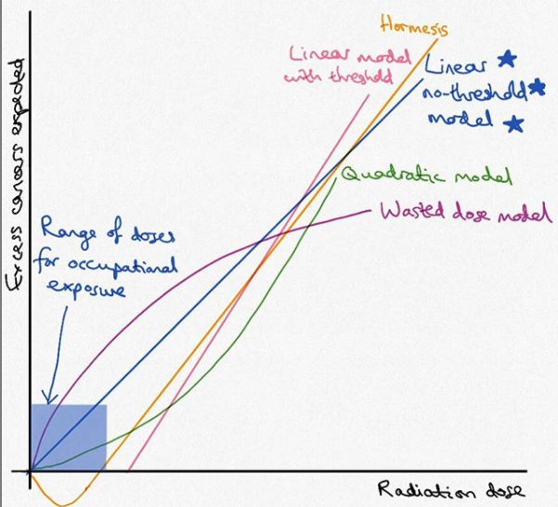](https://www.instagram.com/p/B7QWvOjJxQI/?utm_source=ig_web_copy_link)

## Radiation Protection

* UNSCEAR and BEIR: Estimate risk. ICRP / NCRP: Set standards. NRC / OSHA / State boards: Make and enforce laws.
  + Standard setting bodies: ICRP, NCRP.
  + Regulatory powers: NRC- title 10, Nebraska administrative code 180.
  + FDA: Design of x-ray machines, linacs.
  + DOT label code 7 for radioactivity
    - Transportation:
      * White I: Surface level ≤ 0.05 mSv/h, not detectable at 1m.
      * Yellow II: Surface level ≤ 0.5 mSv/h AND ≤ 0.1 mSv/h at 1 m.
      * Yellow III: Surface levels > 0.5 mSv/h OR > 0.1 mSv/h at 1m.
      * The transportation index is the exposure rate (in mrem/h) at 1 m from the surface of the container.
  + EPA radon-related.
* Absorbed dose is the quantity used to measure ionizing radiation. 1 Sv = 1 J/kg = 100 rem.
  + The stochastic effect depends on the type and energy of radiation.
* **Radiation weighting factors** (WR), aka quality factor are approximate values of RBE: Photon - 1. Electron - 1. Protons - 2. Alpha particles - 20. Neutrons - continuous curve with max of 20 at 1 MeV.
* **Equivalent dose**:HT = D * WR. The average dose absorbed within a single organ [Sv]
* **Effective dose**: **E =∑** HTWT. **The summed weighted tissue equivalents for all organs and tissues within the body** [Sv]
  + Lifetime effective dose should not exceed age in years x 10 mSv.
* **Committed dose**: Integral of dose over 50 years of ingested radionuclide [Sv]
* **Collective dose**: Average equivalent or effective doses x number of people exposed [person-Sv]
* **Collective committed dose**: Same as above but ingested radionuclide [person-Sv]
* Age cumulative maximum: Age * 10mSv.
* ALARA = negligible individual dose of < 0.01 mSv/y.
* **Background radiation**: Terrestrial, cosmic, and internal (due to K-40 in body). All together average of 3 mSv/year.
  + **Baseline ~6 mSv/y** (3 background - 2 mSv Radon, 1 mSv other background, 3 from artificial sources such as x-ray, job, etc.)
    - Background: Florida/Southern coast/Michigan 0.23 mSv/y. 0.46 mSv/y in rest of US, 0.9 mSv/y in Uranium mines in Nevada.
  + **Non-man made**: 11% internal (K-40), 8% cosmic, 8% terrestrial, 55% radon.
    - One banana equivalent measurement is 0.1 μSv.
  + **Man made**: 11% medical rays, 4% nuclear med, 3% consumer products, 1% other.

**Now, man-made radiation dominates at around 52% of all radiation exposure**.

* + Kerala, India has 13 mSv/y without increased risk in cancer rates.
* **EDE limits**: Based on risk of accidental death in "safe" industries. < 1 per 10,000 workers. Medical procedures not included.
  + **Radiation workers**: **50 mSv/y**.
    - TEDE (minimize stochastic) 50 mSv/y.
    - Lens (prevent deterministic) 50 mSv/y (previously 150 mSv/y).
      * Public ED for lens of eye: 15 mSv/y - divide old limit of 150 by 10!
    - TODE (prevent deterministic) 500 mSv/y.
    - Skin (prevent deterministic) 500 mSv/y.
  + **Pregnant workers**: **5 mSv** entire gestation. Embryo **0.5 mSv/mo**.
  + **General public**: **1 mSv/y** ("chronic" exposure) or 5 mSv/y (infrequent) and < 0.02mSv/w (1mSv/y * 1y/52w)
    - 3 mSv for flight attendants.
  + **Nuclear med**:
    - Ensure spouse dose is < 5 mSv, give instructions if total effective dose equivalent to any person is ≥ 1mSv.
    - Don't D/C if rate ≥ 0.02 mSv/h at 1 meter.
  + Permissible radiation levels: **0.1 mSv/wk** in controlled areas and **0.02 mSv/wk** in uncontrolled areas.
    - This is simply the annual dose limit for each population divided by 52 weeks (e.g. 50 mSv/y vs. 1 mSv/y).
* RT-induced cancer: Solid tumor latency at least 10y and does not decrease with time (linear), leukemia 5-7y and risk ends by 20 years (non-linear).
* **Medical event** 
  + Dose delivered varies by: 50 mSv EDE, 500 mSv to an organ/tissue or 500 mSv to the skin AND **Total dose delivered is off by 20% or more** or falls outside prescribed dose range OR Administration of wrong radioactive drug, wrong route, wrong mode, leaking source OR **single dose delivered is off by 50% of more** of the dose expected from administration of the written directive (E.g migrated seed)
* Workload: Weekly dose delivered at 1 meter from the target.

## 

## Radiation Carcinogenesis

* Cancer survivors make up 3.5% of the US population, though second primary malignancies comprise 16% of all cancers diagnosed.
* **Deterministic** = threshold (e.g. cataracts). Severity increases with dose.
  + Cataracts: Proliferating cells are pre-equatorial region. No way to remove damaged cells in lens.
    - Radiation-induced cataracts usually begin from the posterior portion of the lens, while age-related are more commonly in the anterior portion of the lens.
  + 2 Gy/single fraction firm cutoff. Typical fractionation: < 4 Gy no cataracts, >10 Gy 100% cataracts.
  + Average latency = **8 years** (2.5 - 6.5 Gy). The larger the dose, the shorter the latency (e.g. 4 years for 6.5 - 11.5 Gy).
  + Nuclear cataracts are not radiation related.
* **Stochastic** = severity is independent of dose (e.g. cancer).
  + The shortest latency is for leukemia, which is 5-7 years. For solid tumors, latency may be 60+ years.
    - **Leukemia risk: non-linear dose-response which decreases with time** (e.g. linear-quadratic).
    - **Solid tumors with linear risk**.
* **Absolute Risk model**: Leukemia expected after latency, unrelated to baseline incidence.
* **Relative Risk model**: Related to baseline incidence. Example: RR model predicts a larger number of radiation-induced cancer in elderly.
* **Time-dependent Relative Risk model**: Excess incidence in cancer assumed to be a function of dose, square of dose, age at exposure (ex: children may develop thyroid cancer, while girls may develop breast cancer). Favored by BEIR for solid tumors.
  + BEIR VII report of excess risk of lethal cancers for high dose rate of ~10%/Sv, low dose / low dose rate ~5%/Sv.
    - However, this is highly dependent on age and sex (F > M - e.g. excess lifetime risk from 5%/Sv for 50y males to 25%/Sv for 10y females).

## 

## Clinical Response of Normal Tissues

* **Law of Bergonie and Tribondeau** (1906) Tissues appear to be more radiosensitive if their cells are less differentiated, have a greater proliferative capacity and divide more rapidly.
  + Exception: Lymphocyte. Terminally differentiated cell once exposed to an antigen, yet are radiosensitive (D0 = 80 cGy).
* Late effects are much more sensitive to changes in fractionation, as per isoeffect curves.
* A **consequential late effect** is due to persistent severe early effect.
* Structurally undefined FSUs: Clonogenic cells can migrate from one FSU to another, as in re-epithelialization of denuded skin.
* **Casarett's Classification**:
  + Group I - Vegetative intermitotic cells: Erythroblasts, crypt cells, epidermal stem cell. *No differentiation.*
  + Group II - Differentiating intermitotic cells: Myelocytes.
  + Group III - Reverting postmitotic cells (Think: F-type): Liver.
  + Group IV - Fixed postmitotic cells: Nerve / Muscle. *Highly differentiated.*
* **Michalowski's H and F-type populations**:
  + Hierarchical: stem cells.
  + Flexible: No compartments, rarely divide under normal conditions like liver, thyroid, dermis.
* CNS: Neurons, vascular endothelial cells, glial cells.
  + Days/weeks → vascular dmg, edema (think: short course low-dose steroids, memantine may help).
  + Weeks/months→ Transient demyelination (white matter △), early onset leukoencephalopathy.
  + Mo/Years → Vascular abnormalities (grey matter △), necrosis ∴ permanent dementia (long course steroids).
  + α/ß=2 (previously), now 3 by Quentec.
    - How does this change? 60Gy/30F: BED2=120 vs. BED3=100.
    - For fractionated RT with a fraction size of < 2.5Gy.
      * Incidence of radiation necrosis < 3% for < 60 Gy.
      * 5% at BED3 = 120 Gy (range 100-140): 72 Gy in 2 Gy fractions.
      * 10% at BED3 = 150 Gy (range 140-170): 90 Gy in 2 Gy fractions.
    - BID RT has steep toxicity curve when BED3 > 80Gy.
    - >2.5 Gy/fx, incidence and severity of toxicity is unpredictable.
    - Example: Emami: 5% risk of radionecrosis at 5y if 60 Gy/30 to 1/3 of the brain.
* Spinal cord: Lhermitte's may occur at doses as low as 35 Gy, may persist up to a year.
  + TD5/5 = 50 Gy for 10 cm length, 55 Gy for 5 cm length.
  + TD50/5= 70 Gy.
* Bone and cartilage
  + 10 Gy can kill chondroblasts.
  + 20 Gy irreversible.
  + Osteoradionecrosis for large volume of bones is roughly TD5/5=~50 Gy and TD50/5=~65 Gy (based on lower maxilla and humeral and femoral head data).
* Bone marrow stem cells have Do close to 1 Gy (recall D0 is 37% survival, or avg of 1 lethal event per cell).
* The kidney tolerance to re-treatment may decrease with time.
* Compared to bone marrow stem cells, jejunal cells have a very wide shoulder (better at repairing SLD).
* Blood vessels: 50-70 Gy for arterial damage, 40 Gy for capillaries. Veins are very radioresistant.

# Instant Oncology: Physics

[**](https://www.instagram.com/p/B-enUfiAkAQ/?utm_source=ig_web_copy_link)

[](https://www.instagram.com/p/B-gvn1QgdZ3/?utm_source=ig_web_copy_link)

[**](https://www.instagram.com/p/B-aRMvGg4Hn/?utm_source=ig_web_copy_link)

[**](https://www.instagram.com/p/B-MzlA3gO99/?utm_source=ig_web_copy_link)

[**](https://www.instagram.com/p/B9H9O4mA5hn/?utm_source=ig_web_copy_link)

[**](https://www.instagram.com/p/B9GujfGgVJ4/?utm_source=ig_web_copy_link)

[](https://www.instagram.com/p/B8f_O8NAzrt/?utm_source=ig_web_copy_link)

[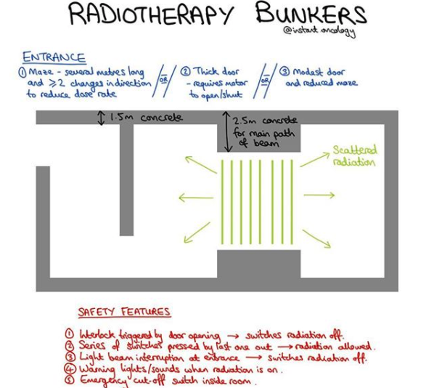](https://www.instagram.com/p/B_ANindAJgp/?utm_source=ig_web_copy_link)

[](https://www.instagram.com/p/B708kE-J6HA/?utm_source=ig_web_copy_link)

[](https://www.instagram.com/p/B7ySUqSJZy4/?utm_source=ig_web_copy_link)

[](https://www.instagram.com/p/B6l2qNtpRpl/?utm_source=ig_web_copy_link)

[](https://www.instagram.com/p/B6yK20upRzd/?utm_source=ig_web_copy_link)

# Instant Oncology: Rad Bio

[](https://www.instagram.com/p/B91PfPlAtz9/?utm_source=ig_web_copy_link)

[](https://www.instagram.com/p/B9tnFdPAvJf/?utm_source=ig_web_copy_link)

[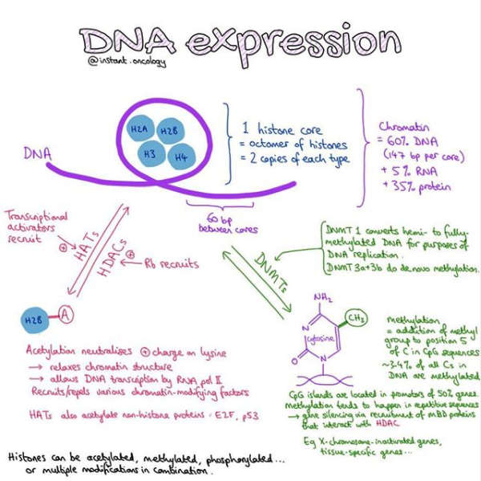](https://www.instagram.com/p/B9ekAB0g3sm/?utm_source=ig_web_copy_link)

[](https://www.instagram.com/p/B8cLggug3pS/?utm_source=ig_web_copy_link)

[](https://www.instagram.com/p/B8KTKtFgQ37/?utm_source=ig_web_copy_link)

[](https://www.instagram.com/p/B7n2HIhJwMR/?utm_source=ig_web_copy_link)

[](https://www.instagram.com/p/B7WJQxHJXMb/?utm_source=ig_web_copy_link)

[](https://www.instagram.com/p/B7QWvOjJxQI/?utm_source=ig_web_copy_link)

[](https://www.instagram.com/p/B6MUKCrBuMO/?utm_source=ig_web_copy_link)

# Instant Oncology: Statistics

[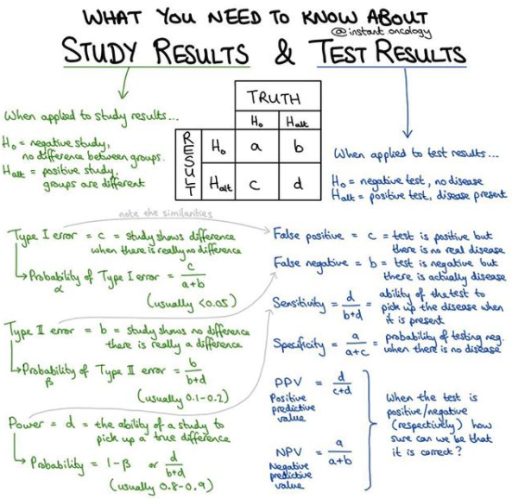](https://www.instagram.com/p/B_IcPHcAD_I/?utm_source=ig_web_copy_link)

[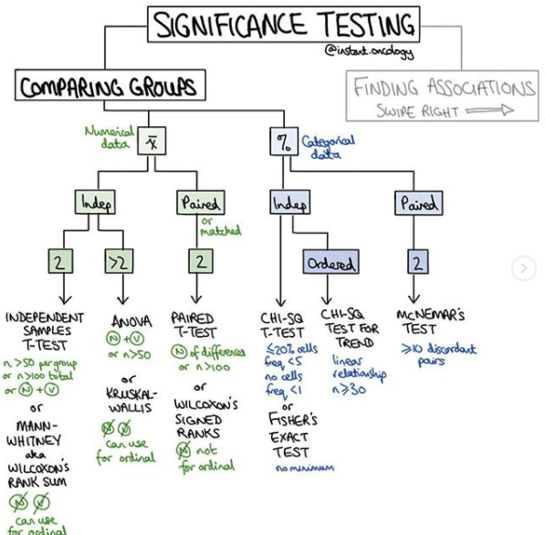](https://www.instagram.com/p/B9RJOccgPsV/?utm_source=ig_web_copy_link)

[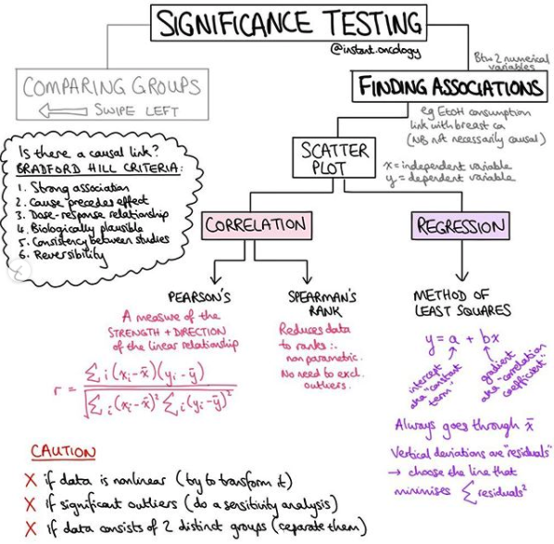](https://www.instagram.com/p/B9RJOccgPsV/?utm_source=ig_web_copy_link)

[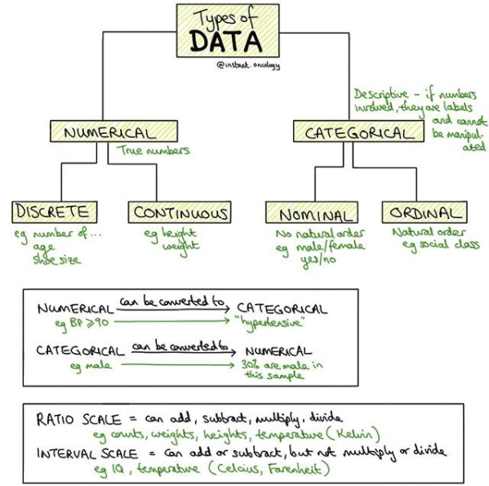](https://www.instagram.com/p/B9M-takg9k-/?utm_source=ig_web_copy_link)

[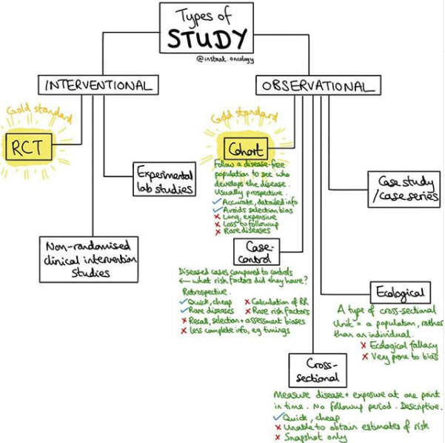](https://www.instagram.com/p/B9LwyzBAUyM/?utm_source=ig_web_copy_link)

# **Biostats**

* Simpson paradox: Trend disappears in meta when combined.
* Westinghouse effect: Observer effect.
* Burali-Forti paradox: data sets in a meta are inappropriately combined.
* Kappa coefficient - when two independent observers agree with each other.
  + Poor agreement = < 0.20.
  + Fair agreement = 0.20 to 0.40
  + Moderate agreement = 0.40 to 0.60
  + Good agreement = 0.60 to 0.80
  + Very good agreement = 0.80 to 1.00
* PPV increases as prevalence increases. Increased specificity (TN) will increase PPV.
  + 1-PPV = chance of not having dz if test positive (e.g. positive CXR in kiddo without hodgkin's disease).
* NPV increases as prevalence decreases. Increased sensitivity (TP) will increase NPV.
  + 1-NPV = chance of having dz if test negative (e.g. reading pCR when disease remains in body).
* Sp = TN / (FP + TN). *Specificity is the probably a test will be negative when the disease is not present.*
* Type I error (α): True null hypothesis is rejected (FP).
* Sn = TP / (FN + TP). *Sensitivity is the probably a test will be positive when the disease is present.*
* Type II error (β): False null hypothesis is accepted (FN).
  + Power = 1 - β , or TN, rejecting a false null hypothesis.
* Sequential tests increase specificity.
* Simultaneous tests increase sensitivity.
* Case control are the quickest and cheapest.
* Phase I - Dose.
* Phase II - Short term effectiveness, adverse events. Or, no standard of care in control arm.
* Standard error 1/ ∝ root(n).